**Milestone report on Activity 5.5.1**

By Abdullahi Bala

**Introduction**

Activity 5.5.1. of the N2Africa project [**Activity 5.5.1. A revised manual for rhizobium methods and standard protocols available on the project website (**[**www.n2africa.net**](http://www.n2africa.net)**)**] requires that a revised manual of Rhizobium methods be available on the project’s website by Month 10 of Year 1 (August 2010). This report provides an update on the attainment of this milestone.

**Rhizobiology training manual**

In preparation for the training course for advancing technical skills in Rhizobiology for technicians in East and Central Africa, which took place in Nairobi in September 2010, the University of Hawaii NifTAL Project’s training manual “Methods of Legume-Rhozobium Technology” (Somasegaran and Hoben, 1985) was revised and used for the training (See attached). The revised copy was also adapted with further modifications for use as a resource material for the trainings in West Africa (November 2010) and southern Africa (September 2011). The revised manual provides the initial attainment of this milestone.

**Writing workshop for Rhizobium Methods Manual**

A writing workshop for Rhizobium Methods Manual was held in Perth Western Australia, from March 14 to March 19 2011. Jointly sponsored by The Crawford Fund, ACIAR, the Bill and Melinda Gates Foundation, GRDC and Murdoch University, the 6-day workshop was attended by experts in the field of Rhizobiology from Australia, Europe, and the Americas. None of the African invitees could attend the workshop for various reasons but they sent in their contributions for some of the chapters. N2Africa had a good representation from John Howieson, Mariangela Hungria and Ken Giller. A draft chapter content for the manual is attached. The manual is undergoing a review and will be uploaded on the project’s website once it is published.

Advancing Technical Skills in Rhizobiology

**A two week training course conducted in the East and Central Africa Hub of the N2Africa Project**

Prepared by Paul L. Woomer, Nancy Karanja and Stanley M. Kisamuli

**Table of Contents**

|  |  |
| --- | --- |
|  | Page |
| Introduction ................................................................................................................. | 2 |
| Training Schedule ....................................................................................................... | 5 |
| **Section 1: Basic Rhizobiology ..................................................................................** | 8 |
| Activity 1: Collecting Root Nodules and Isolating Rhizobium .................................. | 8 |
| Activity 2: Characterizing Rhizobium Cultures .......................................................... | 13 |
| Activity 3: The Growth of Rhizobia ........................................................................... | 16 |
| Activity 4: The Plant Infection Method ...................................................................... | 19 |
| Activity 5: Rhizobium Strain Identification ............................................................... | 22 |
| **Section 2: Strain Selection .......................................................................................** | 25 |
| Activity 6: First-Step Screening for Nitrogen Fixation Potential ............................... | 25 |
| Activity 7: Second–stage Testing in Potted Field Soil ............................................... | 28 |
| Activity 8: Testing Seed Inoculation in the Field ....................................................... | 30 |
| **Section 3: Inoculant Production and Use ...............................................................** | 34 |
| Activity 9: Producing Broth Cultures in Glass Fermentors ....................................... | 34 |
| Activity 10: Preparing Carrier Materials and Producing Inoculants ........................... | 37 |
| Activity 11: Preparing Inoculants Using Diluted Cultures of Rhizobia ..................... | 41 |
| Activity 12: The Use of Legume Inoculants .............................................................. | 43 |
| **Appendices ................................................................................................................** | 48 |
| Appendix 1: Preparing Rhizobium Culture Media ..................................................... | 48 |
| Appendix 2: Preparing Gram and Carbol Fuchsin Stains ........................................... | 51 |
| Appendix 3: Broughton and Dilworth N-free Plant Nutrient Solution ....................... | 52 |
| Appendix 4: Building a Growth Rack for Growth Pouches ....................................... | 53 |
| Appendix 5: Surface Sterilization of Grain Legume Seeds ........................................ | 54 |
| Appendix 6: Preparing Leonard Jars ........................................................................... | 55 |
| Appendix 7: Calculating Most Probable Number ....................................................... | 56 |
| Appendix 8: Preparing Inoculant Carrier Materials .................................................... | 57 |

**Acknowledgement**

Many of the technical procedures presented in this training manual were modified from the University of Hawaii NifTAL Project’s training manual “Methods of Legume-Rhozobium Technology” (Somasegaran and Hoben, 1985) and we sincerely thank them for use of this material.

**Introduction**

N2Africa is a large scale, research and development project focused on putting nitrogen fixation to work for smallholder farmers growing legume crops in Africa. N2Africa is funded by ‘The Bill & Melinda Gates Foundation’ through a grant to Plant Production Systems, Wageningen University, in the Netherlands. It is led by Wageningen University together with CIAT-TSBF, IITA and has many partners in the Democratic Republic of Congo, Ghana, Kenya, Malawi, Mozambique, Nigeria, Rwanda and Zimbabwe. At the end of the 4-year project we will have: identified niches for targeting nitrogen fixing legumes; tested multi-purpose legumes to provide food, animal feed, and improved soil fertility; promoted the adoption of improved legume varieties; supported the development of inoculum production capacity through collaboration with private sector partners; developed and strengthened capacity for legumes research and technology dissemination; and delivered improved varieties of legumes and inoculant technologies to more than 225,000 smallholder farmers. For more information on the project, please visit our website at *www.N2Africa.org*.

An important component of this project is to select superior rhizobia strains for enhanced BNF and develop inoculum production capacity in sub-Saharan Africa, including private sector partners (Project Objective 3). This manual is designed to better align the scientific and technical capacities of project participants to the specific Activities and Milestones within Objective 3 and to identify specific tasks and procedures required to contribute to the overall project.

**Activity 1. Assess the need-to-inoculate for the target legumes and identify elite strains across the impact zones.**

***3.1.1. Protocols for nodule sampling, rhizobia isolation, characterization, evaluation for BNF, competitiveness and persistence updated (month 3, year 1). Task: these c****ourse materials serve as the updated protocols.* Skill set: Project technicians and graduate students must be able to understand and follow updated protocols.

***3.1.2. At least 400 MPN counts and need-to-inoculate trials conducted for soybean and beans, representing existing soil heterogeneity in the impact zones (month 12, year 1).*** *Task: Kenya, Rwanda and DRC must each perform 25 MPNs and field trial pairs for soybean and 33 for bean.* Skill set: construct racks for growth pouches, set up and sanitize greenhouse, surface sterilize and pre-germinate seeds, plant growth pouches, prepare –N nutrient solution, aseptically water growth pouches, select planted growth pouches for uniformity, collect soils from field trial locations, transport and store soils, perform serial dilutions, inoculate growth pouches, read and record nodulation pattern, calculate MPN estimate from table, use MPNES software.

***3.1.3. At least 2,000 strains screened for effectiveness under greenhouse conditions to select the top 5% for field testing (month 6, year 3).*** *Task: two-step greenhouse screening of 500 strains from each of four grain legumes across eight countries for soybean and six countries for bean = at least 65 isolates for soybean from Kenya, Rwanda and DRC and 85 per country for bean.* Skill set: obtain isolates recovered from Activity 3.2.2, surface sterilize and pre-germinate host seeds, assemble, sterilize and plant Leonard jars (or identify rhizobium-free soil), prepare YM broth culture, select plants for uniformity, inoculate plants in Leonard jars, prepare and apply waxed gravel mulch, refill Leonard jar reservoir, harvest Leonard jar, collect and count nodules, dry and weigh shoots, analyze plant growth data, establish strain effectiveness and top 5% of isolates (e.g. top 4 strains of soybean and bean rhizobia). Conduct second round of strain testing with potted greenhouse soil. Set up sterile, gravity-fed nutrient solution dispenser. Select top 2% of isolates (e.g. top 2 strains of soybean and bean rhizobia in each country).

***3.1.4. The benefits of inoculation of soybean and beans with at least 2% of the elite strains demonstrated in the impact zones (month 12, year 3).*** *Task: perform inoculation response field trials on bean and soybean using the best six strains from each hub in collaboration with agronomists from Obj 2.* Skill set: prepare agar slants of 4 cultures and exchange between countries, prepare inoculant from cultures, identify representative field sites, collect soil and conduct MPN, design and install inoculation field trial with two hosts (soybean and bean), six candidate strains per host (top 2%) and three controls (not inoculated, +N and commercial inoculant), resulting in 15 treatments. Inoculate and plant seed, manage field trial, harvest and collect, compile and analyze crop data, interpret benefits of inoculation.

***3.1.5. At least 5 new elite strains significant increased in BNF over the standard strain in production by inoculant manufacturers (month 12, year 4).*** *Task: strains from each country that perform better than, or as well as commercial inoculants are sent to IITA and CIAT-TSBF for further testing.* Skill set: Identify elite strains, prepare cultures for shipment, obtain necessary clearance, ship isolates.

**Activity 2. Establish and characterize a rhizobium germplasm bank in the impact zones**

***3.2.1. Elite strains obtained from leading inoculant producers and rhizobiology laboratories worldwide (month 9, year 1***). *Task: IITA must arrange for elite rhizobia associated with bean, cowpea, groundnut and soybean from other laboratories to be sent to them for characterization and use by project partners. The ECA group has already obtained four elite strains, two for bean (USDA 2667 and CIAT 899) and two for soybean (USDA 110 and SEMIA 5019).* Skill set: identify laboratories and contacts, request strains, arrange import permits and transport, conduct basic characterization similar to Activity 3.2.2.

***3.2.2. At least 10 nodules of soybean and beans collected in at least 200 sites in the impact zones for isolate characterization and inclusion in the germplasm bank (month 4, year 2).***

*Task: Collect 10 root nodules from 25 sites per country, isolate rhizobia, characterize on indicator media and store cultures for further testing.* Skill set: identify legume hosts, collect, select and preserve root nodules, prepare YMA media, isolate 250 rhizobia per country from nodules, authenticate and store culture, transfer cultures to Congo Red and Bromothio Blue YMA plates and describe growth rate and reaction, provide isolates to Activity 3.1.3 for effectiveness screening. Note: collecting 10 nodules from a single experimental field site may be a mistake as it risks recovering redundant isolates of the same strain. Alternatively, nodules may be recovered from the lowest and highest dilutions of the MPNs. Rhizobium exploration skills, where nodules are recovered from extreme environments and various hosts should be included in training.

**Activity 3. Formulate improved inoculant products and develop cost-effective production methods, including quality assurance procedures.**

***3.3.1. Quality assurance protocols are developed for legume inoculants based on existing knowledge (month 6, year 1).*** *Task: Technicians require working knowledge of inoculant production, quality control and labeling requirements.* Skill set: Information required on the legume inoculant package should include: name of the crops for which the inoculant is intended, scientific name and strain(s) of the rhizobiumspecies, number of live rhizobia per gram, expiration date beyond which the product cannot be used, lot number for quality control feedback, instructions for use, net weight of inoculant, trade name, manufacturer and address, and necessary storage conditions. This information is best covered through lecture (e.g. Module 5 of Training Manual). Use examples from commercial inoculant products (e.g. BIOFIX, Rhizo-Stick).

***3.3.2. Cost effective inoculant production methods including fermentation technologies, carrier selection, inoculant formulation, enhanced shelf life developed (month 12, year 2).***

*Task: Each country must establish a pilot inoculant production facility.* Skill set: identify suitable carriers, process, bag and sterilize them, prepare and sterilize glass fermenters, prepare YM broth, inoculate and run fermenter, characterize cell growth, dilute broth culture, dispense to carrier bags, cure inoculant, confirm purity and population density, develop understanding of alternative production approaches (larger fermenters, mixing in trays, liquid formulations with glycerol, addition of PVP). Develop storage and quality control procedures (quantify inoculant rhizobia by plate counts (see Activity 3.2.2) or MPN (see Activity 3.1.2).

***3.3.3. Universal logo representing quality assurance standards adopted among cooperating laboratories (month 6, year 3).*** *Task: Develop a recognizable symbol of inoculant quality based upon project refinements of Activity 3.1.1.* Skill set: Identify current regulation and industry standards applicable in each country (if any), establish a set of standardized inoculant product labeling information, obtain compliance agreement by inoculant producers, design and distribute a universal logo, establish quality control mechanisms, monitor compliance with standards.

**Course Schedule**

|  |  |  |  |
| --- | --- | --- | --- |
|  | **Topic/Activity** | | **Facilitator** |
| ***Sunday 12 September 2010*** | | | |
|  |  | |  |
| Arrival of participants and transfers to KARI Retreat Centre-Muguga | |  |
| ***Day One: Monday 13 September 2010*** | | | |
|  | Registration of participants | | J. Ogala |
| Introduction of participants | | N. Karanja |
| Morning Lecture | Overview of N2Africa project | | K. Dashiell |
| Objective of the training and Objective 3 technical milestones, skill set for project technicians and graduate students. | | S. Koala |
| Key note address and official opening | | Principal-CAVS/Dean Faculty of Agriculture |
| Overview of the training process and activities | | P. Ngokho |
| BNF in African agriculture | | S. Keya |
| Basic rhizobiology, isolating, characterizing and maintaining rhizobia in the laboratory | | N. Karanja |
| ***Tea/Coffee Break*** | | | |
| Morning Practical | Laboratory intro, workstation and partner assignments, media preparation, set up glass fermenters, inoculate broth cultures | | N. Karanja & MIRCEN Team |
| ***Lunch Break*** | | | |
| Afternoon Lecture | Nitrogen and legumes | | P. Woomer |
| ***Tea/Coffee Break*** | | | |
| Afternoon Practical | Legume identification, nodule exploration, recovery and preservation, rhizobium isolation (culture 1), streaking technique, surface sterilizing & pre-germinating seed | | P. Woomer & MIRCEN Team |
| ***Day Two: Tuesday 14 September 2010*** | | | |
| Morning Lecture | Culturing rhizobia, growth requirements and carbon sources, strain characterization & identification | | J. Machua |
| ***Tea/Coffee Break*** | | | |
| Morning Practical | Serial dilutions, quantifying rhizobia by plate counts (culture 2) and plant infection (MPN 1) | | S. Kisamuli & G. Mwenda |
| ***Lunch Break*** | | | |
| Afternoon Lecture | Rhizobia, symbiosis & BNF | | P. Woomer |
| ***Tea/Coffee Break*** | | | |
| Afternoon Practical | Rhizobial growth on indicator media (culture 2 continued), Gram stain, culture storage, PCR demonstration at KEFRI-Muguga | | Joseph Machua |
| ***Day Three: Wednesday 15 September 2010*** | | | |
| Morning Lecture | Inoculants & inoculation | | P. Woomer |
| ***Tea/Coffee Break*** | | | |
| Morning Practical | Seed inoculation technique (slurry, 2-step & pelleting), plate counts of inoculants and inoculated seed (culture 3) | | S. Kasamuli & G.Mwenda |
| ***Lunch Break*** | | | |
| Afternoon Lecture | Producing, marketing and distributing BIOFIX inoculants | | T. Wafulah |
| ***Coffee Break*** | | | |
| Afternoon Practical | Carrier material selection and processing, mixing broth and carrier, field trip to nearby Ndera peat marsh | | T. Wafulah, S. Kisamuli & G. Mwenda |
| ***Day Four: Thursday 16 September 2010*** | | | |
| Morning Lecture | Rhizobium strain authentication and selection, and product testing in the greenhouse. | | Joseph Machua |
| ***Tea/Coffee Break*** | | | |
| Morning Practical | | Greenhouse management, Leonard jars, potted field soil | S. Kisamuli & G. Mwenda |
| ***Lunch Break*** | | | |
| Afternoon Lecture | | Rhizobium strain selection in the field | F. Baijukya |
| ***Coffee Break*** | | | |
| Afternoon Practical | | Field inoculation trials. Experimental design, data collection and analysis | F. Baijukya |
| ***Day Five: Friday 17 September 2010*** | | | |
| Morning Lecture | | Rhizobium strain identification | J. Gitahi |
| ***Tea/Coffee Break*** | | | |
| Morning Practical | | Inspect and purify nodule isolates as needed (cultures 1&2). Agglutination and immunodiffusion. Visit to Vet antiserum lab and rabbit facilities. Preparation of antigens and injecting animals (demonstration) | S. Kisamuli, J. Gitahi |
| ***Lunch Break*** | | | |
| Afternoon Lecture | | Maximizing BNF & response to inoculation | F. Baijukya |
| ***Tea/Coffee Break*** | | | |
| Afternoon Practical | | Objective 2 Field Trials and rhizobiology needs. Linking the rhizobium lab to N2Africa field activities | F. Baijukya & N. Karanja |
| ***Cocktail*** | | | |
| ***Day Six: Saturday 18 September 2010*** | | | |
| Morning | | Field visit to BIOFIX factory (Nakuru) | T. Wafulah |
| Afternoon | | Rift Valley excursion (Lake Naivasha & Hells Gate) |  |
| ***Day Seven: Sunday 19 September 2010*** | | | |
|  | | Free day |  |
| ***Day Eight: Monday 20 September 2010*** | | | |
| Morning Lecture | | Mid-course review, group discussion and mid-course evaluation. What were the strengths and shortcoming of the course’s first week. | K. Dashiell & N. Karanja |
| ***Tea/Coffee Break*** | | | |
| Morning Practical | | Observe colony morphology, inspect and purify nodule isolates as needed (culture 1) | S. Kisamuli & G. Mwenda |
| ***Lunch*** | | | |
| Afternoon Lecture | | Innovation in inoculant production, strain selection strategies, alternative delivery systems | P. Woomer |
| ***Tea/Coffee Break*** | | | |
| Afternoon Practical | | Alternative inoculant production (diluted broth, liquid formulation, granular formulation, others) using broth culture 1 | S. Kisamuli & G. Mwenda |
| ***Day Nine: Tuesday 21 September 2010*** | | | |
| Morning Lecture | | Aligning lab capacity and technician skills to N2Africa project activities and milestones. Lecture and group discussion. | N. Karanja & P. Woomer |
| ***Tea/Coffee Break*** | | | |
|  | | | |
| Morning Practical | | Read plate counts (culture 2) and calculating cell densities. Estimating counts with optical density (demonstration) | S. Kisamuli & G. Mwenda |
| ***Lunch*** | | | |
|  | |  |  |
| Afternoon Lecture | | Most Probable Number by dilution extinction | P. Woomer |
| ***Tea/Coffee Break*** | | | |
| Afternoon Practical | | MPN set up with growth pouches, building racks, planting MPN, preparing –N nutrient solution, aseptic irrigation, selecting for plant uniformity, inoculating the pouch, reading results | P. Woomer, S. Kisamuli & G. Mwenda |
| ***Day Ten: Wednesday 22 September 2010*** | | | |
| Morning Lecture | | Quality control of legume inoculants | N. Karanja |
| ***Tea/Coffee Break*** | | | |
| Morning Practical | | Inoculant quality testing | S. Kisamuli & G. Mwenda |
| ***Lunch Break*** | | | |
| Afternoon Lecture | | Rhizobium exploration: finding better strains | P. Woomer |
| ***Tea/Coffee Break*** | | | |
| Afternoon Practical | | Rhizobium exploration set up, isolation, purification, authentication and characterization | P. Woomer, S. Kisamuli & G. Mwenda |
| ***Day Eleven: Thursday23 September 2010*** | | | |
| Morning Lecture | | Course review and discussion (1) | N.Karanja & P.Woomer |
| ***Tea/Coffee Break*** | | | |
| Morning Practical | | Read plate counts of inoculants and inoculated seed (culture 3). Calculating populations | S. Kasamuli & N. Karanja |
| ***Lunch Break*** | | | |
| Afternoon Lecture | | Facilitating grain legume enterprise and mobilizing BNF technologies | P. Woomer |
| ***Tea/Coffee Break*** | | | |
| Afternoon Practical | | Computer laboratory, calculating populations using excel, the inoculation requirement utility, MPNES practice | P. Woomer |
| ***Day Twelve: Friday 24 September 2010*** | | | |
| Morning Lecture | | Course review and discussion (2) | Team |
| ***Tea/Coffee Break*** | | | |
| Morning Practical | | Completion of lab activities, arrangement for distributing cultures and other materials | Team |
| ***Lunch Break*** | | | |
| Afternoon | | Group discussion, course evaluation | Team |
|  | | Comments from participants representative |  |
|  | | Vote of Thanks | P. Ngokho |
|  | | Closing Remarks | K. Dashiell & N. Karanja |
|  | | Official Closing and award of certificates | Principal-CAVS/Dean Faculty of Agriculture |

Note that mornings are generally devoted to aseptic laboratory activities, and afternoons to field work. Participants depart either on Friday evening or Saturday morning.

**Section 1. Basic Rhizobiology**

**Activity 1: Collecting Root Nodules and Isolating Rhizobium**

The purpose of this exercise is to become familiar with legumes in the field, examine their nodules, isolate rhizobia from nodules and preserve the isolates. The subfamilies in the *Leguminosae* will be discussed and identifications will be made with the help of a botanical key. Nodules will be sectioned and examined. Simple stains of nodule smears will be examined under the microscope. Rhizobia will be isolated from nodules and grown on presumptive test media. The isolates will be authenticated on their original host plants and then preserved on agar slants or ceramic beads.

Key steps

1. Identify legumes in the field, collect nodulated specimens and preserve nodules
2. Examine nodules and bacteroids under the microscope
3. Surface sterilize nodules and isolate rhizobia on differential media
4. Perform Gram stain and re-isolate on differential media
5. Store isolates on agar slants
6. Surface sterilize and pre-germinate seeds for authentication
7. Plant and inoculate seedlings for authentication
8. Examine plants periodically for nodulation and re-isolate

**1. Recognizing Legumes**

***Learn to identify legumes in the field and become familiar with the appearance of the most common agricultural legumes in your area.*** Become familiar with the general taxonomic characters of the *Leguminosae*. Study the different flower types of the three subfamilies: *Caesalpinoideae*, *Mimosoideae* and *Papilionoideae.* Note the main similarities among all legumes in their compound leaves and characteristic pods. Compound leaves are also characteristic of numerous non‑leguminous families such as *Bignoniaceae* (e.g., *Jacaranda* and *Spathodea*) and that other plants form structures similar to pods (e.g. *Moringa*).

**2. Recovering Nodules**

***Identify plants of several legume species in the field and select one representative of each for sampling.*** With a spade, describe a circle with a radius of approximately 15 cm around the plant and cut out this section to a depth of at least 20 cm.  Still using the spade, slowly lift out the clump. Carefully remove the soil from the roots.  Avoid detaching secondary roots from the plant as nodules may be found on the lateral roots as well as the tap root.  Carefully place the whole plant into a plastic bag.  If the legume has seed, collect the seeds for the authentication test. Alternatively, a range of legume hosts may be planted in potted soil, grown for 4-5 weeks and root nodules recovered. In the laboratory, place a sieve of an appropriate size and mesh under each root sample to catch nodules that may become detached from the root.  Carefully wash the roots under a gentle stream of water. The distribution of the nodules on the root system is dependent on the legume species and rhizobial strain as well as soil structure and composition.  Fresh nodules may be stored in the refrigerator overnight.  Do not freeze nodules as ice crystals may rupture and kill the bacteroids.  For longer storage, desiccation in glass vials is recommended.

**3. Examining Nodules and bacteroids**

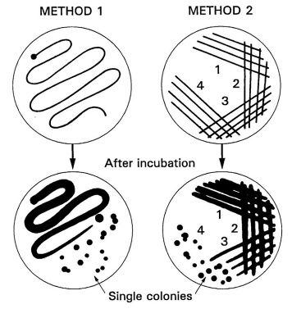

Figure 1. Two methods of streaking bacteria onto an agar plate.

Legume root nodules differ in shape and size depending upon rhizobia and host plant species.  Large round nodules may be found on bean, cowpea, groundnut and soybean plants. Crotolaria, clover, calliandra and acaciaare some legumes that have elongate and branching nodules.  An active N‑fixing nodule contains a protein called leghaemoglobin.  Its presence in the nodule can be noted by the characteristic pink, red, or brown coloration.  Senescent nodules are usually gray and soft. Most ineffective rhizobia cause nodules with green or white interiors that lack leghaemoglobin.

***Cut thin sections of nodules with a razor blade and float them on a drop of water on a microscope slide; use a cover glass and examine under low power (10x) and higher power (40x) objectives.*** Gently rub the cut surface of a nodule on a clean microscope slide to make a smear. Allow the smear to air dry and then pass the slide through a flame.  Cool the slide and stain the smear with dilute carbol fuchsin for 10‑20 seconds.  Wash in water, blot off excess moisture, and air dry.  Examine under the oil immersion objective. Note the irregular size and shape of the bacteroids compared to the rod forms found in pure culture.

**4. Isolating Rhizobia from a Nodule**

Wash roots thoroughly to remove soil.  Collect about 10 nodules from each plant. Sever the nodule from the root by cutting the root about 0.5 cm on each side of the nodule. When moving the nodule, use forceps on the root to reduce the risk of damage. Immerse intact, undamaged nodules for 5‑10 seconds in 95% ethanol or isopropanol (to break the surface tension and to remove air bubbles from the tissue); transfer to a 2.5‑3% (v/v) solution of sodium hypochlorite, and soak for 2-4 min.  Rinse in five changes of sterile water using sterile forceps for transferring. Forceps may be sterilized quickly by dipping in alcohol and flaming.  Utilize sterile glass or plastic petri dishes as containers for the alcohol, sodium hypochlorite and water. A solution of hydrogen peroxide (3% v/v) may also be used for sterilizing nodules. When hydrogen peroxide is used, the 5‑6 rinses with sterile water may be omitted. Desiccated nodules must be rehydrated before sterilizing.  Place nodules into a small beaker with clean cool water and leave in the refrigerator to imbibe overnight.  One hour soaking at room temperature is sufficient for nodules which have been desiccated for only a short time.

Crush the surface sterilized nodule with a pair of blunt-tipped forceps in a large drop of sterile water in a petri dish.  Alternatively, the nodule may be crushed in a sterile test tube with a sterile glass rod.  Streak one loopful of the nodule suspension on a yeast‑mannitol agar (YMA) plate containing Congo Red (CR). Similarly streak one loopful of the nodule suspension on a yeast-mannitol agar (YMA) plate containing bromthymol blue (BTB). The primary isolate may be streaked in one continuous motion as shown in Method 1 of Figure 1. Well isolated colonies may be obtained with Method 2 that is commonly used with isolations from primary plates.

The needle method of isolation is especially useful with freshly harvested nodules 2 mm or larger in diameter.  Wash the nodule first in water, then alcohol, then hold it with forceps and briefly pass it through a flame. Place this surface sterilized nodule on sterile filter paper in a sterile Petri dish.  A new piece of filter paper should be used for each nodule.  The same Petri dish can be used for several nodules.  Dip the blunt tipped forceps into 95% alcohol and flame momentarily.  While holding the nodule with the forceps and resting the nodule on sterile filter paper, quickly slice off a small section with a flamed, hot scalpel.  Still holding the nodule with the forceps on the filter paper, insert the tip of a sterile inoculation needle (with a 1 mm loop) into the cut surface. Load the loop with inoculum.  Streak directly onto a YMA plates containing CR and BTB.

**5. Performing the Presumptive Test**

The plates prepared from the three methods described above are referred to as primary isolation plates.  Incubate these at 25‑30°C in the dark.  After 4‑10 days, look for well isolated colonies.  Pick off a single colony typical of rhizobia and perform a Gram stain, then reisolate by streaking on YMA plates containing CR and BTB. Select isolated typical colonies.  It is possible that more than one type colony (e.g. small and large colonies; mucoid and dry, etc.) may appear on a plate streaked from a single nodule.  Each of these should be streaked on the two media and considered an individual culture.  More than one type of colony in a pure culture of rhizobia may be indicative of variants of the same strain or the occupancy of two different strains in the same nodule. If no isolated colonies develop, restreak a little of the confluent growth again onto each one of the three media.

Incubate and make daily observations for the appearance of colonies typical of rhizobia. Colonies should show little or no Congo Red absorption when incubated in the dark.  A blue color indicative of an alkaline reaction on BTB should be obtained with slow‑growing *Bradyrhizobium* spp.  A yellow color (acid) reaction is usually produced by the fast‑growing *Rhizobium* spp. Plates should be read for reactions after 3‑5 days (fast‑growers, e.g. bean rhizobia) and 5‑7 (slow‑growers, e.g. soybean rhizobia).  Check secondary isolates for colony morphology typical of rhizobia, then perform a Gram stain to check for purity of culture. Transfer two separate colonies to culture tubes to be added to stock cultures.  Stock cultures obtained at this time are considered presumptive rhizobia.  The authenticity of these isolates as pure cultures of rhizobia is confirmed later by the nodulation test (authentication) under controlled conditions. Select two representative colonies of the presumptive rhizobia from the isolation.  Prepare 20‑50 ml broth cultures in duplicates from each of the two colonies. Incubate on a shaker for use in the authentication tests.

Rhizobia grown on YMA + Congo Red and YMA + bromthymol blue serve as presumptive tests for culture purity.  Rhizobia generally do not absorb Congo Red when plates are incubated in the dark.  Colonies remain white, opaque or occasionally pink.  Contaminating organisms usually absorb the red dye.  However, reactions depend on the concentration of Congo Red and age of the culture.  Rhizobia will absorb the red dye if plates are exposed to light during the incubation or exposed to light for an hour or more after growth has occurred. Freshly prepared YMA plates containing bromthymol blue have a pH of 6.8 and are green.  Slow‑growing rhizobia show an alkaline reaction in this medium, turning the dye blue.  Fast‑growing rhizobia show an acid reaction, turning the medium yellow.

**6. Authenticating the Isolates as Rhizobia**

***The importance of determining that the isolate is a pure culture which can form nodules on legume roots cannot be over stressed.  It proves the authenticity of a pure culture of rhizobia.*** For large seeded legumes like beans, soybean, groundnut and cowpea, Leonard jars and growth-pouches are recommended as growth units for authentication.  Alternatively, smaller seeded siratro (*Macroptilium atropurpureum*) may be grown in –N plant nutrient-agar slants.  Siratro is used in authenticating most bradyrhizobia from tropical legumes because it nodulates with more than 90% of all bradyrhizobia including those associated with cowpea, groundnut and promiscuous soybean.

Set up two suitable growth units for each of the isolates plus at least two extra units that will serve as uninoculated controls. Surface sterilize and pregerminate seeds. Inoculate 1 ml of broth culture for each isolate onto each of the pregerminated seeds in two growth units. Plant and inoculate in a clean area.  Take precautions against wind drafts and insects which may cause cross‑contamination between treatments. Examine plants for differences in vigor and color between the inoculated and uninoculated at 15‑30 days of growth.  Remove the plants from the rooting medium and note the presence or absence of nodules.  The presence of nodules in the non‑inoculated treatment invalidates the test.  If the presumptive tests are satisfactory, the isolates are regarded as fully authenticated cultures.  The cultures of presumptive isolates are now confirmed as rhizobia and may be given collection numbers.  When added to a culture collection, other relevant information should be added for each strain such as parent host, site of collection, soil pH, etc.

**7. Preserving Cultures of Rhizobia**

There are a number of satisfactory methods for preserving rhizobial cultures including yeast mannitol agar (YMA) slants in screw‑cap tubes, desiccation on porcelain beads, lyophilized (freeze‑dried), and as frozen liquid suspension under liquid nitrogen. The choice of method will depend on facilities, experience, and resources.  YMA slants and porcelain beads are recommended for laboratories with limited resources (Table 1).

Figure 2. Ceramic bead method storing rhizobium.

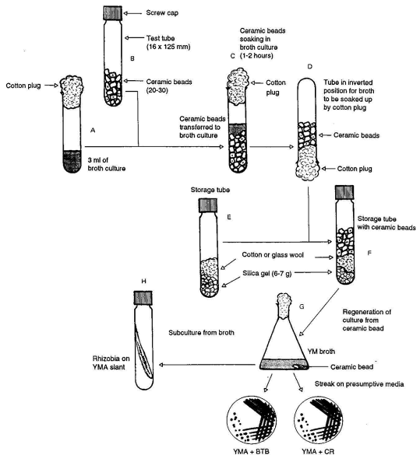

To prepare for storage on beads, inoculate a loopful of culture from a YMA slant into 3 ml of sterile YM‑broth and incubate to maximum turbidity on a rotary shaker. Place 20‑30 ceramic beads (washed and oven dried) in a screw‑cap test tube, cover the mouth of the tube with foil, and sterilize in the oven for 1‑2 h at 160‑170°C.  Prepare storage tubes as depicted in Figure 2 using 6‑7 g silica gel and sufficient cotton or glass-wool to keep the silica gel in place.  The rubber lined caps for the tubes must be autoclaved separately in a rubber beaker, then dried in an oven at 80‑90°C.

The glass-wool may be oven sterilized in the storage tube with the silica gel.  When cotton is used, it should be autoclaved in small balls in a foil covered beaker.  These cotton balls should be of a suitable size to facilitate easy aseptic transfer to the storage tube with forceps.  Residual moisture is removed in the oven at 70‑80°C before transferring it aseptically to the sterile storage tubes. The autoclaved caps are then added to the tubes.

Transfer the sterilized beads aseptically to the broth culture in the tubes and replug. Soak the beads for 1‑2 h, then invert the tube and allow the excess broth culture to soak into the cotton plug. Transfer the beads impregnated with rhizobia into the storage tube aseptically, replace and tighten the screw caps securely. Examine the tubes after a day or so to ensure that the silica gel is still blue.  If it turns pink or colorless, then too much moisture was transferred with the beads or an improper seal is permitting entry of moisture.

To regenerate a culture, inoculate YM‑broth with one or two beads.  These are easily speared from the storage tube using a sterile needle with a slight hook. A week or more may be needed to obtain visual signs of growth.  Once the broth becomes turbid, loopfuls should be streaked on presumptive test media to check for purity.  Subculture from the broth onto YMA slants as desired.

Table 1. Methods for preservation of strains of rhizobium.

|  |  |  |  |  |
| --- | --- | --- | --- | --- |
| Method | Expertise and facilities required | Length of useful storage period | Advantages | Disadvantages |
| Agar slopes in screw cap tubes | Basic microbiological knowledge and facilities for pure culture (autoclave, clean transfer area, tubes, media, etc.) | 1-2 years without transfer at 25-30° but can be longer, if held at 5°C | Simplicity, low cost minimum facilities and expertise | Short storage time, increased chance of contamination and variants because of more frequent subculturing |
| Porcelain beads | As above, plus availability of beads, suitable airtight containers and dry sterilizing facilities for silica gel desiccant | 3-4 years, with some rhizobia significantly shorter with others | Low cost and longer storage time and therefore more time before re-beading. Facility for number of sub cultures (i.e., one bead) from original | Not as long term as lyophilization and risk of contamination and variants when re-beading. |
| Lyophilized or freeze dried | Basic microbiological facilities lyophilizing equipment (vacuum pump, freezing facility under vacuum) ampoules, glass blowing burner, etc. | Minimum 15-20 years experience suggests much longer | Once ampouled, minimal risk of variants or contamination. virtually permanent storage. Can be at room temperature | Expensive for equipment and materials |

**Activity 2: Characterizing Rhizobium Cultures**

The aims of this activity are to distinguish rhizobia from other microorganisms by cell morphology, staining reactions, growth responses on various media, and to show how media for rhizobia can be adjusted.

Key steps

1. Subculture rhizobia and other bacteria
2. Observe cell morphology of rhizobia and other bacteria under phase contrast microscopy
3. Examine rhizobia and other bacteria for cell morphology using a simple stain (carbol fuchsin) and the Gram stain
4. Culture rhizobia and other bacteria on indicator media
5. Observe colony morphology and growth reaction on the indicator media
6. Prepare agar media with different carbon and nitrogen sources
7. Observe growth reactions on each medium

**1. Preliminary Sub-culturing of Different Bacterial Cultures**

Make subcultures on agar slants from the stock cultures of the following microorganisms using YMA slants for the rhizobia, and nutrient agar slants for the other bacteria: *R*. *leguminosarum* bv. Phaseoli (bean rhizobium); *Bradyrhizobium* sp. (cowpea rhizobium); *B. japonicum (soybean rhizobium)*; *Bacillus sp.;* *Pseudomonas* sp.; and *Agrobacterium sp.*

**2. Compare Cell Morphology and Gram Stain Reactions**

***Make wet mounts of the cultures and examine under the phase contrast microscope.  Note the motility, size and shape of the rhizobia compared to other bacteria.*** Place a loopful of sterile distilled water onto a clean, pre-flamed and cooled microscope slide.  Flame the loop and transfer a small sample of the bacterial growth from the slant culture to the water on the slide.  Mix thoroughly and make a thin smear approximately 1 cm2 in diameter. For broth cultures, transfer a loopful and make smear directly on the dry slide.

1. Air dry, heat fix, and allow to cool.
2. Flood the smear with diluted carbol fuchsin for 60 seconds.
3. Rinse carefully in a gentle stream of water and blot dry.
4. Locate smears under low power (10x, 25x, or 40x) objective.
5. Apply a drop of oil to the smear and observe with the 100x oil immersion objective using bright field illumination.

The carbol fuchsin stain makes the bacteria easily visible (cells appear pink).  Note the characteristic rod shape of the cultured cells of rhizobia and compare the size and shape of these to that of bacteroids seen in the nodule preparation.  Also compare rhizobia with the other bacteria and note the difference in size and form.  Refer to Figure 3 for the morphology of the microorganisms.

**3. The Gram Stain Reaction**

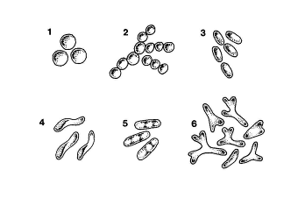

Figure 3. Shapes of bacteria

The Gram stain procedure separates bacteria into two groups: **Gram‑positive** and **Gram‑negative** organisms. **Gram‑positive** organisms retain the crystal violet stain after treating with iodine and washing with alcohol, and appear dark violet after staining (e.g., *Bacillus)*. **Gram‑negative** organisms lose the violet stain after treating with iodine and washing with alcohol but retain the red coloration of the counter‑stain, safranin (e.g., *Rhizobium*, *Pseudomonas*). The procedure follows:

1. Make thin smears of the various bacteria provided and heat fix.
2. Stain the smears with solution 1 (crystal violet) for 1 min.
3. Wash lightly with water and flood with solution II (iodine).
4. Drain immediately and flood again with solution II for 1 min.
5. Drain solution II and decolorize with solution III (95% alcohol) for 15‑30 seconds in the case of a thin smear and 60 seconds if the smear is thick.
6. Wash with water and blot dry carefully.
7. Counter stain with solution IV (safranin) for 1 min.
8. Wash with water and air dry.
9. Observe the preparation under oil immersion.

**4. Characterizing Growth of Rhizobia**

Rhizobia can be described according to their growth in solid and in liquid media. The size, shape, color, and texture of colonies and the ability to alter the pH of the medium are generally stable characteristics useful in defining strains or isolates.  Typical colony characteristics, when grown on standard yeast‑mannitol medium, are described below in Figure 4.

**Shape**: Usually discrete, round colonies varying from flat, domed or even conical vertical shapes on an agar surface (Figure 4).  Colonies usually have a smooth margin.  When growing below the surface in agar, colonies are typically lens‑shaped.



Figure 4. Vertical shapes of bacterial colonies forming on an agar surface.

**Color and texture:** Colonies may be white‑opaque or they may be milky‑ to watery‑translucent.  The opaque colony growth is usually firm with little gum, whereas the less dense colonies are often gummy and soft.  Colonies may be glistening or dull, evenly opaque or translucent, but many colonies develop darker centers of rib‑like markings with age.

**Growth rate**: Generally 3‑5 days for fast‑growers (e.g., frombean, leucaena and sesbania), 5‑7 days for slow‑growers (e.g., from cowpea, groundbut), to longer (8‑12 days from stylosanthes and lupinus) to achieve maximum colony size on agar or growth in liquid medium. Growth rate varies according to the temperature of incubation (optima 25‑30°C), origin (culture or nodule), aeration (in liquid cultures), and composition of medium.

**Size**: When well separated on agar plates, colony size may vary from 1 mm for many slow‑growing strains to 4‑5 mm for faster‑growing strains. In crowded plates colonies remain smaller and discrete but coalesce to confluent growth when colonies join.

**5. Growth Reactions on Modified Carbon Source Media**

Mannitol is generally the best carbon source for rhizobia, but also the least available and most expensive. Other possible carbon sources include sucrose and glycerol. If mannitol is not available, the basic growth medium may be modified, since rhizobia can utilize carbon and nitrogen from various sources. Prepare three types of plates as follows:

1. Prepare 1500 ml of a mineral salts solution containing the constituents of YMA, excluding mannitol. Add 28 grams of agar and heat in the autoclave or water bath.  Dispense the melted mineral salts agar solution in 12 ml portions into test tubes. Sterilize in the autoclave and keep melted in the water bath at 48°C.
2. Prepare carbon source stock solutions (10 g/100 ml) of mannitol (M), sucrose (Su), and glycerol (G).

Pipette into separate, sterile Petri‑dishes 1.5 ml of (2) and 1.5 ml of (3). Pour one test tube (12 ml) of the melted (48°C) mineral salts agar preparation (1) to each plate.

Mix immediately after adding the agar by rotating each dish gently three times clockwise and counterclockwise, and three times to the right and to the left, as well as forward and backwards. Allow the plates to cool overnight for the agar to solidify.  Remove any contaminated plates. After the agar media have solidified, streak one of each of the four provided strains onto one separate plate as you would streak for isolation (Exercise 1) Alternatively, broth cultures of the strains may be surface spread using 0.1 ml portions on separate plates. The streaking of two or more cultures onto one plate may be necessary if there is a shortage of plates. However, this practice should be avoided if possible because of an aerosol effect during the process of streaking. Incubate and compare growth on the various media at 3, 5 and 7 days after plating.

**Exercise 3: The Growth of Rhizobia**

This exercise deals with routine enumeration techniques for pure cultures of rhizobia. The total or direct count is performed using the microscope but is not covered in detail within this activity. Optical density measurements are used to estimate the number of cells in broth culture. The viable count is accomplished through plating methods. The mean generation times of a *Rhizobium* sp. and a *Bradyrhizobium* sp. may be computed by making these measurements over time.

Key steps

1. Inoculate yeast‑mannitol broth with rhizobia
2. Measure the optical density of the broth‑cultures
3. Make a serial dilution and plate by the pour‑plate, spread‑plate, and drop‑plate methods
4. Read and calculate the viable counts obtained by the three methods
5. Compare results of the counting methods

**1. Preliminary Culturing of Fast‑ and Slow‑Growing Rhizobia**

Inoculate two flasks each containing 50 ml of YM‑broth with fast‑growing *Rhizobium leguminosarum* bv. phaseoli strain CIAT 899, and two other flasks with a slow‑growing *Bradyrhizobium japonicum* strain USDA 110. Incubate the flasks at 25‑30°C on a rotary shaker at 20 rpm.  CIAT 899 should be started 4‑5 days in advance of the exercise; USDA 110, 7‑9 days in advance.

**2. Cell Concentration by Optical Density**

The optical density of a bacterial suspension is generally correlated with the number of cells it contains.  Optical density measurements are a simple and convenient estimate of cell numbers as they require but little manipulation, and aseptic conditions need not be observed.

Dilute 5‑10 ml of the CIAT 899 broth culture to 10, 20, 40, and 80% of its original concentration. Measure the light absorbed by each concentration with a spectrophotometer at a wavelength of 540 nm. Use yeast mannitol broth to calibrate the instrument at zero. Relate the different concentrations to the actual cell count obtained from plating procedures that follow. This method also has its limitations. It is best suited for initially clear media. Dead cells and contaminants contribute to the O.D. of the culture, as well as gum produced by the rhizobia, undissolved salt or precipitate in the medium.

**3. Viable Cells by Plating Methods**

Make serial dilutions of the mature CIAT 899 broth culture.  The number of viable cells is approximately 1.0 x 109 ml‑1.  A countable range for plate counts is 30‑300 cells ml‑1.  To achieve this concentration, set out eight tubes each containing 9 ml of sterile diluent (1/4 strength YM broth, pH 6.8). One ml of the broth culture is diluted in steps, tenfold each time (10‑1 through 10‑8). Refer to Figure 5 for the serial dilution procedure.

Figure 5. Procedure for serial dilution.

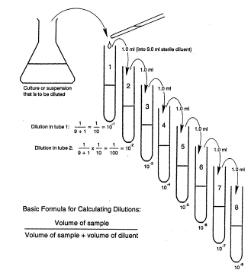

Use a fresh pipette for each strain and for each dilution in the series. Begin with the highest dilution in the series. With the aid of the suction bulb, fill and empty the pipette by sucking in and out 5 times with the diluted culture, then transfer 1 ml aseptically to a sterile Petri dish. Open the Petri dish only sufficiently to allow the pipette to enter and deliver the sample. Flame the pipette briefly (but do not overheat) by passing it through the Bunsen burner flame each time prior to successive removal of aliquots for replication (2 per dilution) from the same tube. Similarly with the same pipette remove 1 ml aliquots in duplicated from the 10-7 and 10-6 dilutions into more Petri dishes.

Pour 15‑20 ml YMA (kept melted at 50°C in a water‑bath) aseptically onto each of the cell suspensions in the Petri dishes.  To disperse the cells evenly, gently move each Petri dish clockwise and counterclockwise allowing an equal number of swirls in each direction. To further ensure uniform dispersion of the cells, move the Petri dish three times forward and backward, then to the left and right.  Allow the agar to set, invert the dishes and incubate at 26‑28°C. Read the plates after 3‑5 days. Lens shaped colonies develop in the YMA and normal colonies develop on the surface.You have now completed the **pour-plate method**.

Multiply the average number of colonies by the dilution‑factor.  The original broth culture concentration = (number of colonies) X (dilution factor) X (vol. of inoculum). If the average number of colonies at 10‑7 dilution is 50, then (50 colonies) X (107) X (1.0 ml) = 50 X 107 cells per ml = 5.0 X 108 cells per ml.

A similar technique called the **spread-plate method** is also commonly used. Use the same serially diluted samples of CIAT 899 prepared for the pour‑plate method above.  Begin with the 10‑7 dilution and deliver 0.1 ml of the sample into each of four plates of YMA previously dried at 37°C for about 2 h.  Using the same pipette, dispense 0.1 ml samples from the 10‑6 and 10‑5 dilutions, in that order.  Prepare a glass spreader by bending a 20 cm glass rod of 4 mm diameter to the shape of a hockey stick, dip it in alcohol, and flame; then cool the spreader by touching it to the surface of a separate YMA‑plate.  Lift the cover of each Petri‑dish just enough to introduce the spreader and place it in position on the agar surface.  Spread the sample evenly over the agar surface, sterilizing and cooling the spreader between samples.  Incubate as before. Calculate the number of viable cells as outlined for the pour‑plate method, adjusting for the smaller volume that was plated (0.1 ml instead of 1.0 ml).

Both of the above methods are lengthy and require a large number of Petri dishes.  A variation known as the Miles and Misra **drop‑plate method** is more rapid and consumes less materials.  Use agar plates which are at least 3 days old or have been dried at 37°C for 2 hours.  Radially mark off eight equal sectors on the outside bottom of the Petri dish. Label four sectors for replications of one dilution and four for another, allowing two dilutions per plate. For this technique calibrated pipettes are required.  Calibrate at least 10 pipettes by determining the weight of 100 drops of water on a sensitive balance or the volume of 100 drops of water in a small measuring cylinder. Calculate the weight or the volume of a single drop by dividing the total weight or volume by 100.

Pipettes with the same tip diameter (e.g., external diameter of 1 mm) deliver drops of virtually the same volume.  After the drop size of a calibrated pipette has been established, more pipettes of the same tip diameter may be selected using a wire‑gauge.  Alternatively, any Pasteur pipette may be cut to the same tip diameter with a fine file after matching its tip with a wire gauge.

Use the dilution series of CIAT 899 which had been prepared earlier.  Plate dilutions of 10‑7, 10‑6, and 10‑5. Using a calibrated Pasteur pipette fitted with a rubber bulb, begin with the highest dilution and deliver 1 drop to each of the appropriate four sectors of the plate. Two dilutions can be shared by one plate. To do this, hold the pipette vertically, about 2 cm above the agar surface, exert just enough pressure on the bulb to deliver one drop.  Use the remaining four sectors of the plate for the next dilution.  Allow the drops to dry by absorption into the agar; then invert and incubate at 26‑28° C.

The drop‑plate method requires more practice than the other methods.  Results may not match those of the pour‑plate and spread‑plate methods at the first attempts.  It is advisable to practice drop‑plating with water before using this method for the first time.  Fewer colonies per drop require more drops to be counted to provide the same statistical precision.

After 3‑5 days of incubation, with daily observations, count the colonies formed by CIAT 899.  Open the Petri dish, invert it, and place on the illuminator of a colony counter.  With a fine tipped felt pen, mark each colony counted while simultaneously operating a tally counter.  Record your counts.  The preferred counting range should be 10-30 colonies per drop.

If a pipette with a 14 gauge tip is used, one drop will be 0.03 ml.  Divide 1 ml by 0.03 and multiply by the dilution factor and the average number of colonies per drop.  Example, if the average number of colonies per drop is 30 at 10-5 dilution, the number of viable cells are:

(1/0.03) X 30 X 105 = 1000 X 105 = 1 X 108/ml

At the end of a 7‑10 day incubation period, count the colonies of TAL 379 on plates prepared by the three methods.  Calculate the number of viable cells per ml and compare the results obtained by the different methods.  Discuss the advantages and disadvantages of the three plating methods.

Bear in mind that plate counts, of whatever variety, are of value only for counting the viable rhizobia in pure culture.  There is no selective medium that permits growth of rhizobium alone. Therefore, quantifying rhizobium in soil is difficult.  Also, the plating methods do not distinguish between strains or species of rhizobium having similar visual colony characteristics on YMA.  When it is necessary to quantify the occurrence of viable cells of a particular rhizobium in non‑sterile materials, a plant infection method must be employed.

**Activity 4: The Plant Infection Method**

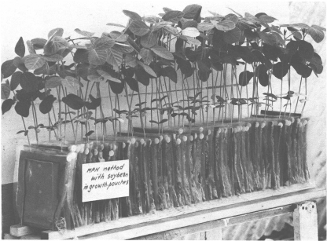

Figure 5. Soybean plants growing in growth pouches.

The plant infection count, also called the most-probable-number (MPN) count, is used to determine the number of viable rhizobia in the presence of other microorganisms. This indirect method is commonly used to determine the quality of inoculants produced from non-sterile carrier materials.  In this exercise, the quality of inoculants prepared separately from presterilized BIOFIX inoculant is determined by the plate count and MPN count methods. The results are compared for agreement between the two methods.

Key steps

1. Prepare growth pouches
2. Surface sterilize and pre-germinate seeds and seeds to growth pouches
3. Prepare serial dilutions of BIOFIX inoculant; initiate MPN and plate counts
4. Make periodic observations of plants and water if needed
5. Count colonies on plates
6. Harvest and record nodulation
7. Determine the MPN
8. Compare results of plant infection and plate counts

**1. Setting up the Plant Dilution Count in Plastic Growth Pouches**

Growth pouches serve well as inexpensive space saving substitutes for Leonard jars.  They are susceptible to contamination introduced by air and insects.  Also, they are not shielded against radiated heat.  Their use is best restricted to growth rooms or shaded greenhouses. Place 30 ml of plant nutrient solution into each growth pouches.  Note that growth pouches are usually sterile but may be sterilized by autoclaving after adding plant nutrient solution. Arrange the pouches in a rack (Figure 6).  Set up one rack of 60 pouches for each bag of inoculant to be tested.  Leonard jars may also used for MPN counts, particularly for large seeded legumes in the greenhouse.

**2. Planting Seeds in Growth Pouches**

Surface sterilize and pre-germinate 100 soybean seeds.  Select seeds of uniform size and high viability (95‑100%).  Use more seeds if the viability rate is lower. Select 60 well germinated seeds of similar size and radical length (1‑1.5 cm).  Transfer one seed to each pouch aseptically. Place each seed in the trough of the paperwick. To prevent the growing radical from pushing the seed out of the pouch, a hole is made in the trough of the wick and the radical is inserted into the hole during planting.  Holes are easily made in the trough with fine tipped, sterile forceps when the wick is wet. Two forceps are needed: one for holding the wick the other for making the hole.

When the plants are 5‑7 days old, reorganize the growth pouches on the rack.  Discard plants of poor growth and select 50 healthy plants.  You will need forty pouches to count dilutions for 10‑1-10‑10 in quadruplicate plus one control pouch following each group of four. This brings the number of pouches needed to 50. Repeat this set‑up in separate racks for each inoculant to be tested.

**3. Inoculating for the MPN Count**

Make a tenfold dilution of each inoculant bags by transferring the content of each bag (100 g) into separate 2.0 liter flasks containing 900 ml of sterile water.  Remove the peat through a cut at one corner of each bag.  Close each flask with a sterile rubber stopper and shake vigorously for 5 minutes by hand.  Make a dilution series for each of the 4 samples from 10-1 to 10-10. Plate the 10‑5, 10‑6, and 10‑7 dilutions of each inoculant in duplicate on YMA‑agar containing Congo Red. Plate in duplicates, incubate at 25‑30°C for 5‑8 days and count rhizobia on plates. Note that inoculants prepared from non-sterile carriers should be plated by the spread‑plate method on YM-agar containing a fungicide such as Brilliant Green (1.25 p.p.m.) or Pentachloronitrobenzene (PCNB) (0.5 g in 100 ml acetone plus 1 drop of Tween 80 added to 400 ml of medium).

Using the same dilution series, inoculate the plants which have been set up for the MPN count.  Pipette 1 ml of each dilution (from 10‑1 ‑ 10‑10) to each one of the four replicates in each set.  Begin by taking aliquots from the highest dilution and proceed down the series with the same pipette. Observe the plants periodically and replenish the nutrient solution if necessary.  Nodulation may be evident after 2 weeks.  Make the final observation after 3 weeks and record presence (+) or absence (‑) of nodules.

**4. Determining the MPN**

For each set, write down the dilutions used and record the nodulation. The actual number of nodules on each plant and the number of plants in each replication have no bearing on the MPN count.  If replications are in quadruplicate, the reading may be 4, 3, 2, 1, or 0 nodulated units.  The highest dilution used should show no nodulation in each replication, indicating the absence of rhizobia. Refer to tables indicating ten-fold dilutions for the estimation of the number of rhizobia by the plant infection method. The number of replications is indicated by "n", and "s" signifies the number of dilution steps.  Each series should end with a dilution at which no nodules are formed.

The MPN is calculated from the most likely number (m) found in the MPN tables.  To find this number, use the procedure shown in the example below:

1. Record nodulation (+ or -) as shown in Table 5.1
2. Take note of the number of replications used (n=4)
3. Count the number of dilution steps used (s=10)
4. Add up the total number of (+) units (+=18)
5. Find this number 22 in Table A.10 (calculated for tenfold dilutions)
6. Locate the most likely number (m) in column s=10, on the same line as 18, which is 5.8 x 103

The MPN may now be calculated from "m" by using the following formula:

m = likely number from the MPN table for the lowest dilution of the series

d = lowest dilution (first unit or any unit in which all replicates are nodulated)

v = volume of aliquot applied to plant

The MPN per gram of inoculant is:

X = m X d = (5.8 X 103) X 102 = 5.8 X 105 rhizobia g-1 inoculant

v 1

Table 2. Example for recording nodulation for the MPN count

|  |  |  |  |  |  |
| --- | --- | --- | --- | --- | --- |
| dilution level | nodulation pattern | | | |  |
|  | ----------- replicate ----------- | | | | number of nodulated units |
|  | 1 | 2 | 3 | 4 |  |
| 10-2 | + | + | + | + | 4 |
| 10-3 | + | + | + | + | 4 |
| 10-4 | + | + | + | + | 4 |
| 10-5 | + | + | + | + | 4 |
| 10-6 | + | - | + | - | 2 |
| 10-7 | - | - | - | - | 0 |
| 10-8 | - | - | - | - | 0 |
| 10-9 | - | - | - | - | 0 |
|  |  |  |  | Total 18 | |

Compare results obtained by the plant infection (MPN) and plate count methods.

**Activity 5: Rhizobium Strain Identification**

**Theory**

Antibodies and antigens migrate towards each other in gel and a line of precipitation is formed where the two reactants meet. The precipitate is soluble in excess of antigen or antibody and thus a sharp line is produced at points of equivalence. The relative position of the line is determined by the concentration of the antigen and antibody in the agar, as well as the molecular size which in turn affects the rate at which the reactants diffuse through the gel.

**Materials and Equipment**

1. 1% Agar in phosphate buffered saline
2. Test sample (Antigen) – from Rhizobia culture
3. Specific antibodies – produced in rabbits
4. Gel punch and immune frame
5. Level table and spirit level
6. Micro-pipettes and tips
7. Humid incubation box
8. Absolute ethanol
9. Blotting papers
10. Trisodium citrate 3%
11. Microscope slides

**Methodology**

**Antigen Extraction: Preparing Antigens for Immunodiffusion.**

When the cultures are ready for harvest, aseptically add about 5 ml of sterile, filtered saline and 10 sterile glass beads to the YMA-slants. Close the culture vessel and hold it level so that the saline irrigates the entire surface. Tilt back and forth so that the glass beads dislodge the rhizobial cells into suspension. Transfer the suspension (but not the glass beads) to sterile centrifuge tubes and spin down the cells at approximately 5,000 X g for 15 min. Discard the supernatant and re-suspend the precipitate again in sterile saline. The gummy substance in the supernatant consists of polysaccharides and is found especially in older cultures. It should be discarded at this point. Do not repeat the centrifugation as excessive washing would remove the soluble antigens essential to the immunodiffusion reaction. Re-suspend the precipitate by drop-wise addition of sterile saline and with frequent agitation to obtain a thick suspension of 1 x 1010 cells ml-1.

Store about one-half of the thick suspension in the refrigerator for reference. Dilute the remainder to 1 x 109 ml-1 using the McFarland standards. Dispense the diluted suspension into small sterile serum vials in 2 ml portions to be used for injections. Add a preservative (1% merthiolate) to each 2ml sample and also to the thick suspension. Merthiolate is used extensively in serology as a preservative. When used in liquids at a final concentration of 1:10000, it does not interfere with serological reactions. The vials may be stored at 40C for several weeks.

**Production of antisera in rabbits**

Pipette 2 ml of antigen and 2 ml of Freund’s complete adjuvant into a 5 ml bottle and emulsify by repeatedly drawing the mixture into a glass or plastic and expelling it through the orifice. The right consistency is reached when a drop of the emulsion does not disperse immediately in water. Freund’s complete adjuvant is made from mineral oil and killed cells of *Mycobacterium tuberculosis* or *M. butyricum*. It is used to enhance the effect of the

Figure 1. Double diffusion slide showing a 6 and 4 well patterns.

antigen.

Inject 1 ml of the antigen-adjuvant emulsion using IM route of the rabbit. After 21 days, give first booster with incomplete Freund’s adjuvant, and bleed the animal(s) at 28th day to test for response.

**Strain identification by Ouchterlony Double diffusion:**

**Slide preparation**

1. Slide is labelled using a diamond pencil and placed on a level table.
2. 1% Agar is melted in a microwave and 4.5 mls poured on to the labeled microscope slide.
3. After the agar has polymerized place the slide onto the immune-frame and punch a six/four-well pattern, depending on the number of samples to be identified.
4. Plugs are removed by use of a pump or hooked needle.

**Sample application**

1. The centre well-A (Figure 1) is filled with the specific antibody against Rhizobium under test.
2. The peripheral wells 2 to 4or 6 (figure 1) are filled with 5 (five) different test antigens. Well 1 is then filled with the control antigen (Positive test).
3. The slide (s) is incubated in a humid box at RT overnight or 18 hours.

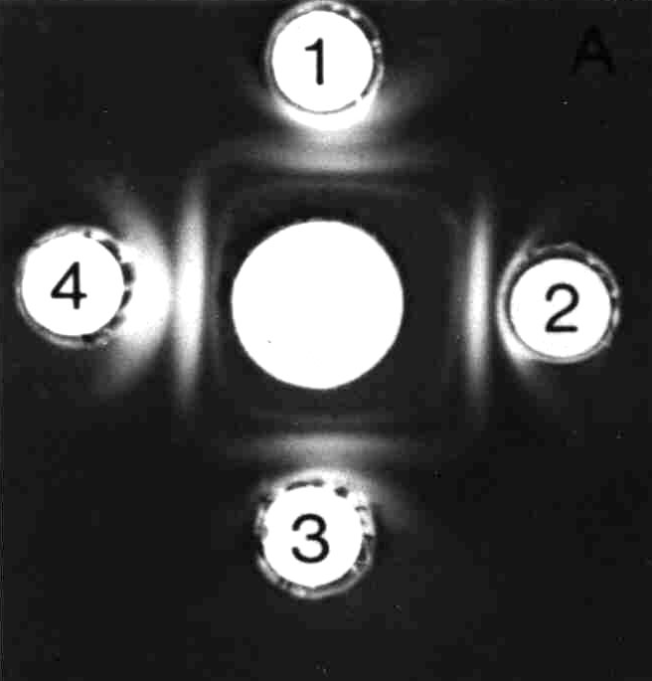

Figure x. Immunodiffusion reactions showing preciption bands.

**Result interpretation**

1. Precipitation lines are observed under white – light and recorded in the data entry forms (see Figure x)
2. Using attached catalogue the species identity is established and reported.
3. In case of weak reactions/lines not visible, the slide is processed and stained to enhance visualisation.

**Slide preparation and staining**

1. Slide is washed with tap water.
2. Washed slides are placed in a level – pressing table and several layers of blotting paper placed on. A small weight is placed onto the blotting paper for 2 hours.
3. Pressed slides are removed and washed by flooding with 3% tri-sodium citrate for 2 hours.
4. A second pressing is done as above for ½ to 1 hr, and slides washed in tap/distilled water.
5. Dried slides are stained with a protein stain for 3 to 5 minutes.
6. - Resultant lines are observed on the side-reviewer after destaining with a destaining solution to satisfaction. - Interpretation of the results done as explained earlier.

**Agglutination Technique**

Agglutination is the reaction between specific antibody and antigen at points of concentration equivalence. One of the reactants MUST be particulate or corpuscular (insoluble). The reaction results to visible clumping that can be done on a coloured plate/slide. Particulate reactant can be bacteria cells, animal cells and synthetic polymers with particle size greater than 200µm. agglutination reaction takes few minutes (3min) with a sensitivity level of 1µg.

**Preparing Somatic Antigens for the Agglutination Antibody Techniques**

The insoluble somatic antigens found on the surface of the cells are required. Soluble and most of the flagella antigens are eliminated by frequent washing. Harvest a fully grown culture from YMA-flats as for immunodiffusion above. Cells should be centrifuged, the supernatant discarded, and the pellet re-suspended in filter sterilized saline, using a vortex mixer. This sequence of centrifugation and re-suspension is repeated three times and the cell concentration is adjusted to approximately 1 x 109 cells ml-1. Transfer the suspension to a sterile serum bottle and close with a rubber septum. Heat the antigen for 1 h at 1000C to inactivate any remaining flagella antigens. This is accomplished by partly immersing the serum bottle in boiling water or by subjecting it to heat in a steam bath.

Agglutination requirements:

1. Saline 0.85%
2. Glass slides
3. Microbiological loop and Bunsen burner
4. Light source over dark background

**Slide agglutination test**

**Step1**. Put two separate drops approx. 50µl of saline on a glass slide. Emulsify the portions the Rhizobia culture under test with a loop in each drop of saline to make a smooth dense suspension.

**Step 2.** To one suspension (Control) add one drop saline and mix. To the second suspension add one drop of undiluted antiserum and mix.

**Step 3.** Rock the slide gently for one minute and observe for visible agglutination using indirect lighting over a dark background. Discard the used slide fer safe disinfection and disposal

**Reference**

Andreson and Hayden. 1981. Species specificity in themostable and ethanol insoluble tissue antigens, Immunization (incomplete reference).

**Section 2: Strain Testing**

**Activity 6: First-Step Screening for Nitrogen Fixation Potential**

Specificity and promiscuity in the symbioses are studied in cross-inoculation experiments using four different legume hosts and three rhizobium strains in Leonard jars. The specific requirements of certain legumes for particular rhizobia are demonstrated. The nitrogen fixation potential of the strains is also compared by collecting plant growth data and analyzing the results.

Key steps/objectives:

1. Culture strains of rhizobia
2. Prepare seedling‑agar tubes and Leonard jars
3. Prepare water‑agar plates and surface sterilize, and germinate seeds
4. Plant pregerminated seeds in Leonard jars and thin
5. Inoculate seedlings in Leonard jars
6. Make periodic observations of nodulation
7. Harvest after 5 weeks, collect data and evaluate results

**1. Culturing Strains of Rhizobia**

Culture each of the *Rhizobium leguminosarum* bv. *phaseoli* and *Bradyrhizobium* spp. listed in Table 3 in 100 ml of YM broth in 250 ml Erlenmeyer flasks.

**2. Preparing Leonard Jars**

Set up 48 Leonard jars with nitrogen‑free nutrient solution.

Table 3. Strains of Rhizobium and hosts according to cross-inoculation groups

|  |  |  |
| --- | --- | --- |
| Strain | Rhizobial species | Host legume |
| TAL 169 | *Bradyrhizobium* sp. | *Vigna unguiculata* cv. KARI 274 |
| TAL 169 | *Bradyrhizobium* sp. | Glycine max cv. SB 19 (promiscuous) |
| USDA 110 | *B. japonicum* | *Glycine max* cv. Gazelle (specific) |
| CIAT 899 | *R.leguminosarum* bv. *phaseoli* | *Phaseolus vulgaris* cv. Mavuno |

Each treatment (rhizobial species‑legume host combination and controls) in this exercise will be done in duplicate.  Refer to Table 4 for the treatments and the various combinations to test genetic compatibility between rhizobia and legumes.

**3. Preparing Germination Plates and Surface Sterilizing Seeds**

Make 300 ml of 0.75% (w/v) water‑agar in a 500 ml flask and sterilize.  Pour 25 ml of melted water‑agar into 12 or more Petri dishes and allow to cool.  Check percentage germination of each legume species in advance of experiment.  Batches of seeds with more than 70% viability will be suitable.  Select undamaged seeds for uniformity in size and color.  Surface sterilize enough seeds (at least 200 of each species) to give at least 100 germinated seeds.

Surface sterilize the seeds by immersion in a 3% sodium hypochlorite solution for 3‑5 min. (To prepare 3% sodium hypochlorite solution, add 10 parts of commercial bleach [5.25% sodium hypochlorite] to 7.5 parts of water.) Note that hard seed‑coated species such as calliandra, leucaena and siratro) may be scarified and sterilized simultaneously by immersion for 10 min in concentrated sulfuric acid.  Drain off all excess acid prior to rinsing with sterile water.

Rinse seeds with six to eight changes of sterile water after surface sterilization. Allow the seeds to imbibe water by soaking for 1 h and then rinse twice more.  Transfer the seeds aseptically to agar plates with a spoon‑shaped spatula. Each batch of 100 seeds should be dispensed evenly in four water‑agar plates and incubated at 25‑30°C.

**4. Planting and Inoculating**

Make three well‑spaced holes in the rooting medium to a depth that will accommodate the pregerminated seeds 1 cm below the surface.  Pick up well germinated seeds with sterile forceps and place one seed in each hole with the radicle entering first.  Proper orientation of the radicle during planting is important to ensure proper emergence of the shoot and establishment of the seedling. After placement of the seed, inoculate (1 ml per seed) with the rhizobial culture and cover the hole with the rooting medium.  If vermiculite is used as the rooting medium, autoclaving will cause swelling and loosening of the vermiculite.  This leads to poor anchorage of the root. Therefore, gentle compacting of the vermiculite will be required before planting/sowing of the seeds. Firmness of the rooting medium can be restored by pressing it down with the bottom (sterilized by flaming) of a 125 ml Erlenmeyer flask. After planting and inoculation are completed, add sterile gravel over the surface of the rooting medium.  Set up six jars for each variety.

Thin plants in the Leonard jars to two uniform plants per jar after 5 days.  Excise the shoot of the unwanted plant aseptically using scissors. Avoid disturbing the rooting medium during thinning. To facilitate proper inoculation, carefully clear (with a sterile glass rod) the rooting medium around the root of the plant, to a depth of 1 cm. Dispense drops of rhizobial culture (totaling 1 ml) into the cleared area around the root. Use a fresh pipette for each strain of rhizobia. Place the inoculated jars on the benches in the greenhouse.

**5. Evaluating the Experiment**

Examine the plants over a period of 5 weeks.  Note color and growth.  Replenish Leonard jars with sterile water as required.  At the end of the fifth week, excise the tops and determine their dry weight (dry for 48 h at 70°C). Remove roots from the jars and tubes and wash them free of rooting medium. Where nodules are present, describe nodule shape, size, pigmentation, and distribution.

Note cross‑inoculation groups as recorded in Table 4 and the ineffectiveness and effectiveness of each rhizobial species‑legume combination. Effectiveness will be apparent from the green coloration of the plant and abundant nodules that are red/pink when sliced open.

Table 5. A data sheet for recording presence (+) or absence (-) of nodules in each rhizobia/legume combination.

|  |  |  |  |  |
| --- | --- | --- | --- | --- |
| Rhizobium strain | -------------------------- Legume variety ------------------------- | | | |
|  | Soybean Gazelle | Soybean SB 19 | Cowpea KARI 274 | Bean Mavuno |
| *B. japonicum* USDA 110 |  |  |  |  |
| *Bradyrhizobium* sp. TAL 169 |  |  |  |  |
| *R. l.* bv. phaseoli CIAT 899 |  |  |  |  |
| Uninoculated control |  |  |  |  |

Roots and adhering rooting medium are dislodged into a coarse sieve.  Wash the rooting medium from the roots using a gentle stream of water.  Describe the nodule distribution as prolific tap‑root nodulation; occasional nodules on lateral roots and distant from the tap‑root; large numbers of small nodules; small number of large nodules or nodules absent.  Detach the nodules, count them, determine their total fresh weight, and place them in vials or aluminum foil weighing‑boats for drying.  Dry the nodules to constant weight at 70°C for 2 days.  Nodule harvest from each Leonard jar must be treated individually as in the case of the shoots so do not pool nodules of the three replicates of any one treatment into a single vial.

Determine dry weight of shoots and of nodules for all treatments. Perform an analysis of variance on the dry weight data of shoots and nodules. Plot the mean shoot weight (Y‑axis) against the mean nodule dry weight (X‑axis).  Determine the correlation coefficient (r) of the plot and test the significance of r at the 5% and 1% levels of confidence. Draw the "best" regression line on your plot after determining the regression equation for the regression line. Shoot weight and nodule weight are usually highly correlated, thus shoot weight is used routinely as an indicator of relative strain effectiveness. Other parameters that are highly correlated with shoot weight are total nitrogen of shoot and nodule dry weight.

**Activity 7: Second–stage Testing in Potted Field Soil**

Strains of rhizobia previously screened in Leonard jars are evaluated further in potted field soil.  The effectiveness of mixed and single strain inocula are compared.  Infective native rhizobial populations in field soil are determined.

Key steps

1. Select strains, hosts, treatments and experimental design
2. Collect soil from test field
3. Prepare soil, determine pH and total N content
4. Pot the soil
5. Determine water holding ability (field capacity) of soil
6. Apply fertilizer
7. Plant and inoculate surface sterilized seeds
8. Thin seedlings to desired number
9. Inspect for nodulation and perform MPN counts
10. Water and observe plants
11. Harvest plants, examine nodulation
12. Analyze data

**1. Designing the Experiment and Treatments**

The experimental design is a randomized complete block with three replicates.  There are 6 treatments: three single strain inoculations; one treatment receiving BIOFIX inoculant; a plus N control without inoculation; and a non‑inoculated controls.  Pots are sown with eight seeds and thinned to four uniform plants following emergence.

All of the 3 cultures of *Bradyrhizobia*, TAL 169, USDA 110 and SEMIA 5019 are evaluated in soil.  Inoculate each strain into 70 ml of yeast‑mannitol broth contained in 125 ml Erlenmeyer flasks.  Allow strains to grow for 5‑7 days to reach maximum turbidity (approximately 1 x 109 cells ml‑1).

**2. Selecting and Preparing the Field Soil**

The ideal site for soil collection is the one where a field experiment is to be conducted.  The site soil should be low in nitrogen.  The native rhizobial population should be less than 103 rhizobia per g soil; no previous history of inoculation and cultivation with the intended legume; and with no history of waterlogging or salinity.

With a steel spade or other suitable implement, obtain field soil from a depth of 10‑15 cm.  Soil samples should be taken randomly within a soil type.  Collect and transport approximately 150 kg of soil in strong plastic bags to a clean room.  Spread clean, plastic sheets or tarpaulins, spread the soil and allow to air dry.  Mix the soil thoroughly and remove debris, breaking lumps with a wooden mallet.  Sift the soil through a 5 mm mesh screen. Determine the soil pH and if the soil is acid, add lime to pH 6.0.  Mix the soil and lime thoroughly and equilibrate for 7 days.  During the equilibration period, cover the soil with a plastic sheet.  Obtain clean plastic pots 16 cm in diameter and 18 cm height with a capacity of three liters and drainage holes.  Place 2.5 kg of soil in each pot.

**3. Applying Fertilizer**

The fertility of the soil must be adjusted to optimal levels to obtain good growth of the plants.  The following fertilizer treatments are recommended.  Rates per pot have been calculated on the basis of 2.5 kg-soil per pot.

1. Phosphorus: 100 kg P ha‑1 applied as 1250 kg ha‑1 SSP = 1.5 g pot‑1
2. Potassium: 200 kg K ha‑1 applied as 382 kg ha‑1 KCl = 0.4 g pot‑1
3. Nitrogen: for N-control, 100 kg N ha‑1 applied as 384 kg ha‑1 CAN = 0.4 g pot‑1 25% of N (0.1 g) is applied at planting and the remaining 75% (0.3 g) after 3 weeks.

Add the fertilizers and mix the soil in each pot thoroughly to ensure uniform distribution of the nutrients, Thorough mixing is readily achieved by removing the soil from the pot, placing into a 5 liter plastic bag and shaking. Gently tamp the pots on the floor to slightly compact the soil.  Field capacity is suitable for most plants (about 1.7 liters water per pot). Alternatively, determine the field capacity of the moist field soil using a simple method.

**4. Planting and Inoculating the Seeds**

At the planting rate of eight seeds per pot, a total of 24 seeds are needed for each treatment in triplicate.  From a batch of seeds with good germination, select 200 seeds and imbibe water for 1 hour.  Plant 8 seeds per pot to a depth of 2 cm.  Inoculate each seed with 1 ml of the culture. Label the treatments and assign block numbers. Water the soil in the pots to just below field capacity. Add gravel mulch to control contamination. Randomize the pots on the greenhouse bench. Thin the plants to four uniform plants per pot 5 days after emergence by cutting the stems at mulch level.

**5. Watering the Pots and Making Periodic Observations**

During active growth and fixation, legumes will use a considerable amount of water each day.  During this period, the pots need to be watered regularly.  Water the pots more than once each day if needed. Weigh selected pots showing vigorously growing plants to determine the volume of water needed to replace the water lost.  If there are large differences in plant growth, pots should be watered to weight on a pot by pot basis. Measure out the required volume of water in a measuring cylinder and pour into the pot without excessively disturbing the soil.  Keep plants well watered and make growth observations periodically.

**6. Harvesting and Analyzing the Experiment**

Harvest the plants at 35 days.  Determine dry weight of shoots and nodules for all treatments.  Perform an analysis of variance on the dry weight data of shoots and nodules. Plot the mean shoot weight (Y‑axis) against the mean nodule dry weight (X‑axis).  Determine the correlation coefficient (r) of the plot and test the significance of r at the 5% and 1% levels of confidence. Draw the "best" regression line on your plot after determining the regression equation for the regression line. Shoot weight and nodule weight are usually highly correlated, thus shoot weight is used routinely as an indicator of relative strain effectiveness. Other parameters that are highly correlated with shoot weight are total nitrogen of shoot and nodule dry weight.

**Activity 8: Testing Rhizobia and Seed Inoculation in the Field**

Strains of rhizobia previously selected in potted field soil may be evaluated in the field to identify the most effective strains for inoculant production.  The advantages of a multi‑strain inoculant may also be compared with single‑strain inoculants.

Key steps

1. Select rhizobial strains and prepare the inoculants
2. Prepare the field and apply fertilizers
3. Inoculate the seeds and plant
4. Determine the number of rhizobia on the inoculated seeds
5. Inspect the field and weed as necessary
6. Harvest at 50% flowering (early harvest)
7. Harvest for grain yield (final harvest)
8. Analyze the data

Figure x. Field layout and dimensions of a trial with three replicate blocks containing five test strains and three controls.

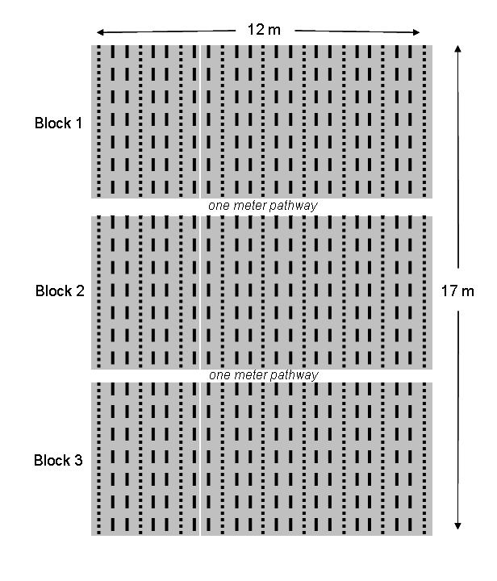

**Set up.** Install the experiment as a randomized complete block with three replications (Figure x).  Set up six treatments; four inoculated (three single‑strain and one multi‑strain noculant); a plus‑nitrogen; and non‑inoculated control without nitrogen. A field area of 204 m2 (74 m x 12 m) is required.  Make rows 5 m in length and 0.5 m apart.  Each treatment is flanked by an uninoculated guard (border) rows along each side, with two center harvest rows.  The area of each treatment is 5 m2 and the area harvested for grain yield is 3 m2 (= 0,0003 ha).

Choice of rhizobial strains: Use the five best test strains, according to their order of ranking in Activity 7.  Compare these strains to a commercial inoculant in use by farmers.

**Preparing inoculants.** In this experiment, inoculate the seeds (except controls) with peat cultures prepared from the test strains. The procedure for preparing inoculants is presented in Activity 10. Rather than a commercial inoculant, the individual strains may compared to a mixed strain inoculant containing the three best strains from Activity 7. Aseptically mix equal volumes of each strain in a sterile Erlenmeyer flask. Use this mixture to inoculate the peat. Prepare the inoculants in advance of the experiment and allow them to mature for at least 2

weeks at 25‑30°C.

Figure x. The design of a replicate block containing five test strains and three control treatments, a commercial inoculant, nitrogen fertilizer and a non-inoculated control.

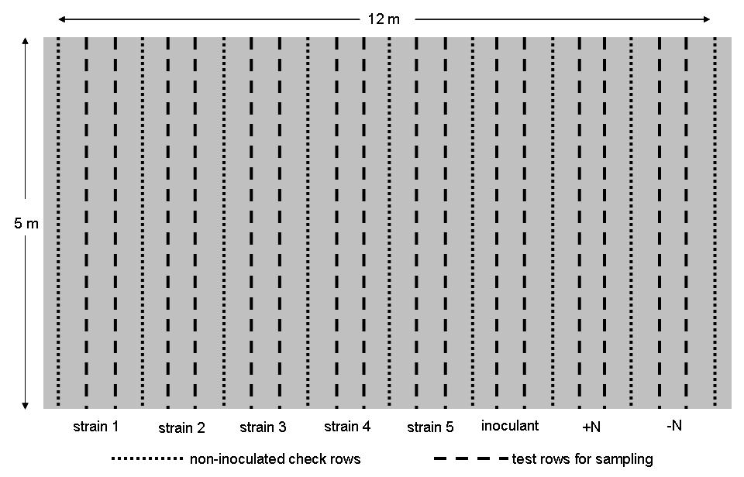

**Preparing seeds for inoculation and planting**. A planting distance of 10 cm between seeds is optimal for good soybean yields.  Based on this planting distance, approximately 50 seeds are needed per 5 m row.  Since there are two inoculated rows and one check row per treatment plot (plus one extra check row), eight treatments and three replications, a total of 3750 seeds will be needed for the trial (about 750 g).  Count or weigh seeds making allowances for losses and for samples to be taken for determining the number of rhizobia per seed at planting.  Weigh out the seeds for each treatment in clean plastic bags and label accordingly.

For soybean, 1 g of peat‑based inoculant and 2 ml of gum arabic for 100 g of seed are recommended for experiments.  Inoculate the seeds using the two-step method as described in Activity 12. Inoculate the seeds just before planting.  Keep the seeds in their plastic bags and in a cool place away from direct sunlight. One option is to set aside 20 seeds of each inoculated treatment and with minimum delay determine the number of rhizobia per seed (inoculation rate) as described in Activity 12.

**Preparing the field.** Drive stakes into the soil at the four corners of the field to indicate the boundary of the experimental site.  Clear and remove all surface vegetation with care taken to remove weedy grasses by their roots. Till the field to a depth of 15-20 cm.  Remove large rocks, plant roots, and other forms of debris.  Break up lumps and prepare a smooth, firm seed bed. Alternatively, the sowing may be done without plowing using Conservation Agriculture approaches. This will minimize disturbance to the soil and release of soil nitrogen. Mark the replicate plots and designate treatments within the different plots. Treatment positions should be randomized in advance of planting and recorded. Separate blocks with a one meter wide pathway for better access to the experiment.

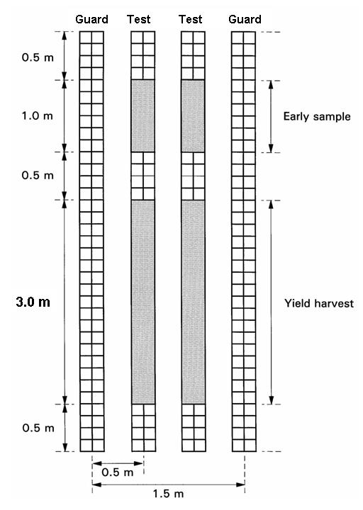

Figure x. Sampling strategy for the field trial.

When preparing the field, one must remember that rhizobia are soil bacteria and are easily spread by the movement of soil or water. Surface overflow resulting from heavy rains and the flood‑irrigation method may cause serious cross‑contamination. Cross‑contamination from rainwash may be controlled by the preparing elevated seed beds, resulting in shallow ditches between the seed beds. Planting along the contour and digging shallow ditches uphill from the experiment also reduced water movement.

**Applying fertilizer.** Fertilize the field soil to optimize conditions for plant growth and nodulation.  Acid soils may be limed to pH 6.0‑6.5.  Apply lime two weeks prior to the application of the other fertilizers. Broadcast phosphorus fertilizer, either single super phosphate (SSP) or triple super phosphate (TSP), across the 60 m2 blocks with care taken to avoid pathways.  If using SSP broadcast 2.8 kg per block or with TSP apply 1.2 kg. Depending on specific conditions each block may also receive potassium chloride (3.0 kg), zinc sulphate, 0.3 kg) or magnesium sulfate (0.4 kg). Do not mix urea with the other fertilizers as this is applied at planting only to the plus‑N controls.  Incorporate fertilizers into the soil soon after application.

**Planting the experiment.** Prepare furrows 5 m long, 0.5 m apart and 3 cm in depth.  Make furrows for only a few plots at a time so that open furrows are not subjected to drying out from prolonged exposure in the sun. Plant seeds at 10 cm spacing. A two m long wooden stick with 10 cm graduations may be placed alongside the furrow to provide a useful guide for even placement of seeds. Plant the controls and guard rows first and cover the seeds on completion of each row to reduce cross-contamination.

Also, prevent contamination of the seeds by sterilizing your hands when handling each batch of seeds inoculated with a different strain.  Hands are easily sterilized by thorough washing with soap and water followed by swabbing with alcohol after the hands are dry.

Apply urea only to the plus‑nitrogen controls in split applications at the rate of 100 g per plot, half at planting and the remainder after at 4 weeks.

**Monitoring the trial and interpreting results**. Inspect the field frequently for plant damage by disease and insect pests.  Take appropriate measures to control these pests.  Weed the plots whenever necessary.

Make frequent observations of plant growth and color.  Note treatments with early signs of N fixation. Record the time taken for 50% of plant population to initiate flowering.  Make an early harvest at this time.

The area of the plots for early harvest and harvest for grain yield are indicated in Figure x.  Harvest plants for dry matter yield.  Observe nodule size, color, and distribution on the root.  Obtain the fresh and dry weight of nodules. Record time for the plants to reach maturity.  Process the plants for determining grain yield (dried to 5‑6% storage moisture).  Express grain yield on a kg ha‑1 basis. Compare the performance of the strains to the commercial inoculants and nitrogen fertilizer. Rank the data obtained for grain yield.

**Section 3: Inoculant Production and Use**

**Activity 9: Producing Broth Cultures in Simple Glass Fermentors**

Glass fermenters are set up in a laboratory and used for the small scale production of broth cultures. The broth cultures are monitored periodically for cell number and contamination during growth.

Key steps

1. Initiate starter broth cultures
2. Assemble small fermentor units
3. Sterilize fermentors
4. Become familiar with operation details
5. Inoculate the fermentors
6. Test for contamination
7. Perform viable counts by the spread plate method on the presumptive test media

**1. Inoculating Starter Cultures**

Prepare a 50 ml flask containing 25 ml of YMB.  Obtain slant, or lyophilized bead preserved cultures of bradyrhizobia (*B. japonicum* USDA 110) and fast growing rhizobia (*Rhizobium* leguminosarum bv. phaseoli CIAT 899).  Inoculate two flasks with each rhizobial strain and aerate at 25‑30°C.  These will serve as "starter" cultures for inoculating the YMB in the fermentors.

**2. Assembling Simple Fermentors**

Set up two fermentors (one for each strain) as shown in Figure 6.  The main fermentation vessel is a slightly modified 4 l Erlenmeyer flask with a sampling port (glass tubing 4 mm ID) fitted close to its base. Fill each fermentor with 2‑3 l of YMB.  Connect the cotton packed filters to prevent the entry of contaminants via the air lines.  All rubber stoppers and tubings must be autoclavable.  Insert the large rubber stopper which holds the air inlet and outlet tubes with their respective filters, firmly into the neck of the flask.

Connect the air inlet tube to an aquarium pump.  Activate the pump and check the air inlet and outlet filters for air resistance.  Air should flow freely through both filters while bubbling through the broth and simultaneously aerating and agitating the medium.  The cotton in the filters should be packed uniformly but loosely.  Overpacking the air inlet filter can cause resistance to incoming air and lead to poor aeration.  Overpacking of the outlet filter can lead to poor air escape and pressure build‑up in the fermentor.

Disconnect the fermentor from the pump and prepare it for autoclaving.  Make sure that the stopper which holds the air tubes is still firmly seated.  The air supply system must be well protected to prevent entry of contaminants.  Wrap the top of each flask with a wide band of non‑absorbent cotton and secure it with a string.  Then, add a protective wrapper of aluminum foil (Figure 20.2).  Close the air inlet tube with a clamp at the spot indicated in Figure 20.1 to prevent the broth from leaving the flask due to pressure build up in the flask during autoclaving.  Pressure relief during autoclaving occurs through the air outlet tube which must be left open.  The filters should remain connected to the fermentor during autoclaving.  To provide a convenient place for them, make an oversized wire ring to fit snugly around the neck of the fermentor vessel and twist it to obtain an eyelet or loop on each side.  Each filter may then also be fitted with a piece of wire ending in a small hook. Hook the filters onto the eyelet (Figure 6). Sterilize the assembly for 40 min, if it contains approximately 2 l of broth. Adjust the sterilization time according to the volume of liquid; increase time by 10 min for each additional liter.

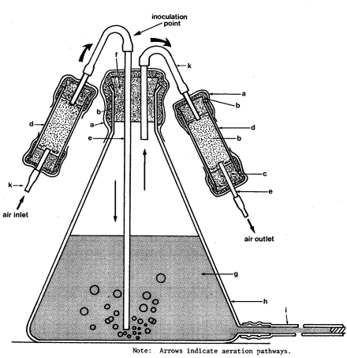

Figure 6. Scheme of simple fermentor unit a ‑ Aluminum foil; b ‑ Non absorbent cotton; c ‑ Autoclavable stopper; d ‑ Filter unit; e ‑ Glass tubing; f ‑ Wire ring; g ‑ Growth medium; h ‑ Flask; i ‑ Sampling tube; j ‑ Plug; k ‑ Latex tubing; l ‑ Hose clamp; m - Aquarium pump; n - Wire hook

After the fermentor has cooled, remove the clamp from the air inlet tubing.  Connect the air supply to check for proper aeration once again and for leaks in the system. Various types of air systems have been used to aerate small fermentors including compressors, compressed air in tanks, aspirators, and aquarium pumps.  The latter have been very satisfactory for small units and are inexpensive, silent, and dependable. Although a pressure relief valve may be desirable, it is not really necessary. Most aquarium pumps generate only low pressure, sufficient however, for several (four) fermentor units which may be connected to one aquarium pump using a manifold.

**3. Operating the Glass Fermentors**

General operation:  If, after autoclaving, the fermentor has been inspected and found to function properly, it is ready for inoculation with the starter culture.  If an aquarium pump is used, and more than one fermentor is attached, adjust the air to achieve an equal flow to each fermentor.  For other air supply systems, adjust the air flow on the bypass which may be installed between the pump and the air inlet filter.

The glass fermentor is inoculated through the latex air inlet, just above the main stopper tubing, with a sterilized syringe fitted with an 18 G needle.  Care must be taken that no contaminants are introduced.  Twenty ml of the starter culture are removed aseptically from its flask.  The air inlet tubing is swabbed with 70% alcohol (or 3% hydrogen peroxide) about one inch above its connection to the glass tube.  The needle is inserted downwards into the tubing and the culture is injected.  The airstream will facilitate speedy entry and incorporation of the starter inoculum into the YMB.  The culture is incubated at 25‑30°C under continuous aeration.

Sampling procedures:  Aseptically, with a sterile syringe, withdraw culture broth from the fermentor through the sampling tubing attached to the sampling port.  Swab the tubing with 70% alcohol or 3% hydrogen peroxide.  Insert the needle into the sterilized portion of the tubing and withdraw the desired amount of culture broth. For quality control purposes (such as Gram stain, pH measurements, optical density measurements, the total count, and plate counts), 5‑10 ml of culture are sufficient and may be withdrawn by using a 5 or 10 ml syringe fitted with a 22 gauge needle.

For injection of the broth culture into bags of sterile carrier (peat), 40 ml samples are usually withdrawn with a sterile 50 ml syringe fitted with a 18 gauge needle.  Alternatively, an automatic motorized syringe equipped with a 16 gauge needle may also be used to withdraw broth culture if large numbers of bags are to be injected.

**4. Producing YMA Broth for Inoculant**

When the starter cultures have reached the end of their log phase of growth (7 days for a slow‑growing rhizobia and 5 days for a fast‑­growing rhizobia, respectively), they are ready to be used for inoculating the fermentor. Inoculate one fermentor with USDA 110 and the other with the fast‑growing CIAT 899. When broth cultures are mature, they may be incorporated into carrier material after purity of culture has been established.

**Activity 10: Preparing Carrier Materials and Producing Inoculants**

Carriers for rhizobia are prepared from various materials including peat, charcoal, sugar cane factory filter mud, and vermiculite.  These carriers are used for the production of granular and powdered inoculants.  In this activity, the characteristics of these inoculants is tested and compared, and they are combined with YMA broth to produce seed rhizobium inoculant.

Key steps

1. Select and dry carrier materials
2. Grind, sift and neutralize carrier materials
3. Determine water holding capacity of carriers
4. Package and sterilize the carriers
5. Examine the carriers for sterility after sterilization
6. Inoculate carriers with broth cultures from fermentors
7. Plate peat cultures for quality control
8. Apply quality standards

**1. Milling Inoculant Carrier Materials**

Carrier materials are chosen to fill criteria set forth in the introduction to this section.  This activity compares peat, filter mud and charcoal.  Inspect each material for foreign materials, weigh 2 kg of each carrier and grind it in a hammer mill.  Thoroughly clean the hammer mill with a brush or with a jet of air from a compressor before grinding the next carrier. Pass the ground material through a set of sieves: 42 mesh (355 μm) and 200 mesh (75 μm).  If available a sieve shaker may be used by placing the sieves on a collecting pan, and clamp the stack and collecting pan to a sieve shaker after 60 min.  Whether by hand or shaker, collect the fraction caught on the the pan.  The remainder should be returned to the mill and ground again.  Particles of 200 mesh and finer, make carriers suitable for seed coating.

**2. Preparing and Characterizing Inoculant Carriers**

The pH of an inoculant carrier should be around 6.5‑7.0.  In a 400 ml glass beaker suspend 10 g of the carrier into 90 ml water.  Stir the mixture on a magnetic stirrer while monitoring the pH with the electrode of a pH meter.  If the pH is lower than 6.5, gradually add precipitated, powdered calcium carbonate (CaCO3) until a pH of 6.5 has been reached.  Record the amount of (CaCO3) needed to neutralize 10 g of the carrier.  Add a corresponding amount to the remaining carrier. For example, if 0.25 g were needed to neutralize 10 g of carrier in the water suspension, add 2.5 g of CaCO3 to every 100 g of dry carrier.  Mix well by hand.  Repeat the same procedure for all carriers.

The water (moisture) holding capacity of a carrier determines the maximum amount of liquid inoculum that can be added to it.  Carriers vary greatly in their water holding capacity. Before the water‑holding capacity can be measured, the inherent moisture level in the carrier must be determined. Weigh 10 g accurately on a foil or glass weighing dish and place it into the oven at 70°C for 24 h.  Weigh and return to the oven.  Another weighing at 48 h will confirm the endpoint of moisture loss. Use the formula below to calculate the inherent moisture content on the dry weight basis.

*Moisture content = [(initial weight-final weight) x 100]/final weight*

Next, determine the moisture‑holding capacity of the carrier.  Weigh 100 g of oven dried carrier material into a 500 ml beaker.  Add water with continuous stirring, until the carrier appears to be saturated. Add additional water to produce a thin slurry.  Transfer this slurry to a pre‑weighed measuring cylinder which has a drain hole on its bottom covered by a sieve.  Allow the water to drain overnight, then weigh the measuring cylinder with the contents.  Give the moisture holding capacity on the dry weight basis of the carrier.  For example, if 100 g of predried carrier can hold 120 ml of water, its moisture holding capacity is 120%.

The amount of inoculum broth to be added to the carrier must be well below the carrier's moisture holding capacity as the resulting inoculum should be friable in texture.  It is, however, desirable to add the largest amount possible while still retaining the desirable texture.  A high moisture level is necessary because moisture is lost during storage, and the survival of rhizobia in a carrier is affected by low moisture levels.

Proceed to determine the desirable amount of moisture to be added to the carrier by a trial and error method.  Prepare six bags (polyethylene 127 x 178 x 0.076 mm) of each neutralized carrier (50 g per bag).  To the first bag, add an amount of water which is approximately 5 ml less than the carrier's moisture‑holding capacity.  If this moisture holding capacity is 60 ml (or 120%) add 55 ml.  To the next bag, add 5 ml less (50 ml).  Continue until each successive bag has received 5 ml less than the preceding one. Thus, bag #6 will receive 30 ml of water.  Seal the bags with a bag sealer and incorporate the water into the carrier by kneading.  Knead or massage the bags thoroughly until all moisture has been absorbed and the carrier/water mixture appears to be homogenous. Examine the bags for total absorption of the water.  Check for dry areas in the carrier which can usually be recognized, as unwetted carrier has a lighter color.

Allow the six treatments to equilibrate for two hours, then cut the bags open and sample a few grams of each bag with your hand.  A suitable carrier/water mixture should feel moist, but not soggy.  It should crumble in your hand, be friable and not sticky.  From each representative carrier select that treatment which has absorbed a maximum amount of water while still retaining friability.  Record the carrier:water ratio and use this information to calculate the recommended moisture level for each carrier.  The recommended moisture level is usually given in percent calculated on the wet weight basis of the final preparation.  The inherent moisture level of the carrier must of course be taken into consideration.  The total moisture content of the inoculant is the sum of the weights of broth culture and inherent moisture of the carrier.  Thus, a 90 g package of inoculum with a moisture content of 50%, made from a carrier with an inherent moisture level of 10%, contains 45 g of dry carrier, 5 g of inherent moisture and 40 g of broth inoculum. Determine the moisture holding capacity of all the carriers used, then prepare them as outlined in Table x.  A similar table may be made for the granular carriers.  Record the moisture holding capacities in the last column of the table.

Gamma‑irradiation (5 megarads) is preferred for peat sterilization over autoclaving.  Gamma‑irradiated peat is used here in one treatment only since irradiated peat is often unavailable.  It serves as a standard because its properties as carrier material for various strains of rhizobia are well known. Weigh 50 g portions of all other carriers into autoclavable polypropylene bags. Add 1 ml of water per bag. Make an incomplete heat seal leaving the bags slightly open. Autoclave the bags in a foil covered tray. After the bags are cool, completely heat-seal in a sterile hood.

Table 21.1. Carrier types, treatments, and quantities required for inoculant preparation and evaluation using finely milled carriers.

|  |  |  |  |
| --- | --- | --- | --- |
| Carrier | Sterilization | Quantity | Moisture Level |
| Peat | gamma-irradiated | 4 bags x 50 g | tbd (≈ 50%) |
| Peat | autoclaved | 4 bags x 50 g | tbd (≈ 50%) |
| Peat | not sterilized | 4 bags x 50 g | tbd (≈ 50%) |
| Filter mud | autoclaved | 4 bags x 50 g | tbd (≈ 45%) |
| Filter mud | not sterilized | 4 bags x 50 g | tbd (≈ 45%) |
| Charcoal | autoclaved | 4 bags x 50 g | tbd (≈ 35%) |
| Charcoal | not sterilized | 4 bags x 50 g | tbd (≈ 35%) |

tbd = to be determined.

**3. Producing Inoculants**

Prepare inoculants as described in Table x. Obtain the fermentor cultures of soybean rhizobium USDA 110 and bean rhizobium CIAT 899 that were produced in Activity 8. The presterilized carrier materials in sealed bags are aseptically injected with the suitable amount of broth culture with a sterile 50 ml syringe fitted with a sterile 18 gauge needle. Withdraw the desired amount of broth culture from the outlet tubing of the glass fermentor as described in Activity 8.  Sterilize a small area in a corner of the carrier bag with 70% ethanol.  Puncture the bag in the sterilized area and insert the needle carefully to avoid piercing the opposite wall of the bag.  Inject the desired amount of inoculum aiming the tip of the needle toward the center of the bag.

Seal the puncture hole with plastic labeling tape and write on it the treatment number, the strain used, and the date of preparation.  Work the broth into the peat by kneading the bags until the liquid inoculum has been uniformly absorbed by the carrier.  Incubate at 25‑30°C for 2 weeks. Rhizobia in the various treatments are expected to reach their maximal population two weeks after inoculation, a period referred to as curing the inoculant..

**4. Testing the Quality of the Inoculants**

The inoculant preparation of autoclaved filter mud resembles the commercial product BIOFIX. Determine the number of viable rhizobia BIOFIX inoculants for soybean inoculants prepared from different carriers and sterilization procedures. Make serial dilutions of the nine samples plus BIOFIX.  Plate duplicate dilutions ranging from 10‑4 to 10‑7 on YMA + Congo Red and on YMA + BTB.  If proper aseptic procedures are not fully observed, contaminants may be accidentally introduced during the injection of the broth culture and during serial dilution and plating.  Such contaminants will usually be detectable on these indicator media and their number should also be reported.

The hand-mixed inoculants, especially those based on nonsterilized carriers, can be expected to contain abundant contaminants and the plant-infection count will be necessary for a reliable determination. Plate counts on indicator media may be used to give a measure of the contaminants.

**5. Collecting, Recording and Analyzing the Data**

Determine the number of viable rhizobial cells in the various carrier treatments. Transform the data to log10 and calculate the mean for the replications. Organize the data in the format as shown in Table x.

Table x. Multiplication of soybean inoculant containing USDA 110 prepared from various carriers and under different sterility conditions.

|  |  |  |  |
| --- | --- | --- | --- |
| Carrier treatment | Carrier material | | |
|  | Peat | Filter mud | Charcoal |
|  | ---------------------- log10 rhizobia per g inoculant ---------------------- | | |
| irradiated |  |  |  |
| autoclaved |  |  |  |
| unsterilized |  |  |  |

Examine the results critically and contemplate the following questions:

1. Are all treatments well above the NifTAL minimum standard for inoculants at expiration?
2. Which level of sterility contributes to the highest cell population?
3. How are the carriers affected by the sterilization measures with respect to their ability to support high cell populations?
4. Why are different counting methods suggested for different levels of sterility?

**Activity 11: Preparing Inoculants Using Diluted Cultures of Rhizobia**

The production capacity of small-scale inoculant production plants using pre-sterilized peat can be increased by using diluted liquid cultures of rhizobia. In this exercise, fully grown cultures are diluted prior to incorporation into pre-sterilized peat in packages.

Key steps

1. Culture *Rhizobium* sp. and *Bradyrhizobium* sp. (from Activity 8)
2. Make culture dilution flasks
3. Prepare diluents in dilution flasks
4. Prepare and package peat
5. Prepare diluted cultures and inject diluted cultures into peat

**1. Culturing Rhizobia in YMB**

During Activity 8, 500 ml YMB is prepared in each of two 1 liter Erlenmeyer flasks using   a slow growing USDA 110 and a fast growing CIAT 899.  After 4 to 7 days, respectively, a late log phase culture is obtained and checked for purity. This broth culture is also used to prepare the dilution flasks in this activity as well.

**2. Making a Culture Dilution Flask and its Operation**

The culture dilution flask is basically a 2 l Erlenmeyer flask modified by a short glass‑tubing outlet at the base of the flask as shown in Figure x.  Seek the assistance of a skilled glass‑blower for fitting the glass tubing to the base of the flask. Five culture dilution flasks are required per rhizobial strain (four for diluents and one for the undiluted culture as control, see Table x).

Attach a piece of surgical latex tubing of suitable size to the glass tubing outlet of each dilution vessel.  Close the open end of the latex tubing with a plug made from a short piece of glass rod.  Add appropriate diluent, cover the flask, and sterilize the entire unit by autoclaving.

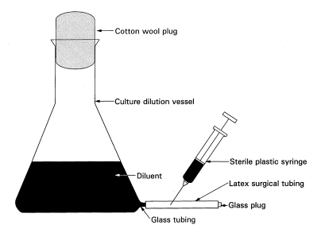

Figure x. Apparatus for diluting cultures of rhizobia.

To dilute the culture, aseptically introduce (with a pipette or a hypodermic plastic syringe fitted with a 3.5 cm and 14 gauge needle) the fully grown culture via the mouth of the culture dilution flask.  Swirl the flask to ensure proper mixing and dilution of the culture in the diluent.

Withdraw the diluted culture for inoculation with a sterile plastic syringe as described for the fermentor in Exercise 20.

**Preparing the Diluents**

The late log phase cultures of each strain are diluted in 20% (v/v) solutions of yeast mannitol broth (YMB) and yeast sucrose broth (YSB).  YSB has the same ingredients as YMB except that sucrose (10 g/l) is substituted for mannitol.

Prepare 500 ml of 20% YMB and YSB by mixing 100 ml of full strength media with 400 ml of distilled (or deionized) water in the culture dilution flasks. Prepare each diluent in duplicate since two strains will be used.  Sterilize the diluents by autoclaving in the dilution flask.

Only sterile peat is recommended for inoculant production by the dilution procedure. However, inoculants have been prepared from peat with surviving contaminants, as long as the contaminants were not detectable at dilutions higher than 10‑2. Irradiation sometimes does not provide absolute sterility, but the dilution method still produces high-quality inoculants in irradiated peat carriers.

**Preparing Diluted Cultures of Rhizobia**

The various diluents prepared are used for diluting the late log phase cultures of USDA 110 and CIAT 899. Perform serial dilutions for viable counts using the spread‑plate method.  Immediately after performing viable counts with the undiluted culture, accurately pipette 1 ml of the broth culture of USDA 102 into 500 ml of the 20% YMB in the dilution‑flask to obtain a diluted culture.  (The diluted culture will contain approximately 2‑10 x 106 cells ml‑1, based on the assumption that the original undiluted culture had at least 1‑5 x 109 viable cells ml‑1.  Complete the preparation of diluted cultures of TAL 102 with YSB. Similarly, prepare diluted cultures of CIAT 899 using the various diluents in the dilution flasks.

**Preparing Inoculants with Pre-sterilized Peat**

Aseptically, with a 50 ml plastic syringe, inject 30 ml of the diluted culture into each package of autoclaved peat or 40 ml in the irradiated peat.  Massage or knead the inoculated bags to work the inoculum into the peat.  Label the bags to indicate the appropriate treatment and the date.  Incubate the packages at 25‑30°C.  Since many biological, chemical, and physical factors influence the multiplication and survival of rhizobia in carriers, examine the data and contemplate the following questions.

Did the inoculants produced with diluted cultures reach maximum populations compared to the undiluted culture control?

Can you confidently recognize colonies formed by rhizobia on plates in the presence of colonies formed by other microorganisms during plate counts?

**Activity 12: The Use of Legume Inoculants**

The purpose of this activity is to demonstrate the preparation of stickers, methods of coating seeds with inoculant and a seed pelleting technique. Sticker materials are recommended to bind the rhizobia to the seed. The stickers used in the following demonstrations are gum arabic and sugar, and are compared to water. Both of these adhesives must be dissolved in water before use. Two seed coating methods are used. The ***slurry method*** and the ***two-step method***. In the ***slurry method***, inoculant is first mixed with the sticker. The resulting slurry is then applied to the seeds. The ***two-step method*** requires seed coating in two stages. First, the seeds are coated with the sticker. The inoculant is then added and coated onto the sticky seeds. Note that the amounts of sticker used for each method vary with seed size (Table 1) and in this practical soybean seeds are used. Under certain conditions, it is advisable to ***pellet inoculated seeds*** with a protective layer of powdered calcium carbonate or rock phosphate. This treatment is most commonly done with seeds of pasture legumes, but may also be practiced with grain legumes, particularly where grown in highly weathered and nutrient depleted soils. The pellet is applied after seed coating by either the slurry method or the two-step method. The seeds are rolled in the pelleting material immediately after inoculation while they are still wet and sticky.

Table 1. The amounts of sticker, inoculant and mineral coating required for selected grain legumes.

|  |  |  |  |  |  |  |  |  |
| --- | --- | --- | --- | --- | --- | --- | --- | --- |
| legume | seed | ----- slurry method ----- | | ----- two-step method ----- | | ---------- two-step pelleting ---------- | | |
| seed | weight | sticker | inoculant | sticker | inoculant | sticker | inoculant | coating |
|  | g/seed | ml/kg seed | g/kg seed | ml/kg seed | g/kg seed | ml/kg seed | g/kg seed | g/kg seed |
| **soybean** | **0.14** | **30** | **10** | **20** | **10** | **40** | **10** | **200** |
| bush bean | 0.42 | 22 | 10 | 19 | 10 | 33 | 10 | 160 |
| climbing bean | 0.45 | 20 | 10 | 18 | 10 | 30 | 10 | 150 |
| groundnut | 0.50 | 18 | 10 | 16 | 10 | 25 | 10 | 100 |
| cowpea | 0.14 | 30 | 10 | 25 | 10 | 40 | 10 | 200 |

Key steps

1. Preparing the sticker

2. Inoculating legume seeds using the slurry method

3. Inoculating seeds using the two-step method

4. Inoculating larger amounts of seed

5. Pelleting Seeds

6. Determining the Number of Viable Rhizobia on Seeds

**Materials.** The amounts of materials needed should be gauged according to the number of participants in the exercise. The list of materials below is based on 9 to 15 participants divided into three groups.

1. 500 ml bottled water (x9)
2. Tablespoon for measuring (x3)
3. Teaspoon for measuring (x3)
4. Two liter plastic bags (x12)
5. Wooden stirring spoon (x3)
6. Small plastic funnel (x3)
7. Marking pen (x3)
8. Plastic buckets, 3 liter capacity (x3)
9. Plastic bucket, 20 liter capacity with lid
10. Gum Arabic, granular (3 x 200 g)
11. Sugar, granular (3 x 100 g)
12. Agricultural lime (calcium carbonate), finely powdered (3 x 200 g)
13. Soybean inoculant (3 packs x 100 g)
14. Soybean seed (12 kg in 1 kg bags)
15. Paper sheets (x27)

Note that measurements are provided in grams, liters and milliliters. In the field it is more practical to convert these volumes and measurements into more convenient units. One level teaspoon holds five ml of sticker and one heaped teaspoon of inoculant contains five grams. Three teaspoons make one tablespoon.

**1. Preparing the sticker**

***Gum arabic.*** Heat 500 ml water in plastic containers by placing them in the sun (or on the dashboard of a auto) for 1 hour prior to the demonstration. Open bottle, remove 200 ml of water, add 150 g of gum arabic (or 4 teaspoons) using the plastic funnel and shake until dissolved. Set aside to cool. This procedure results in a 30% gum arabic solution. Mark the plastic bottle as containing gum arabic solution. If the weather is cloudy and cool, it may be necessary to warm the water over a stove to dissolve the gum arabic, and replace it into the plastic bottle using the funnel.

***Sugar.*** Remove about 100 ml of water from a 500 ml water bottle. Add 75 grams of sugar using the plastic funnel. Shake until dissolved. This procedure results in a 15% sugar solution. Mark the plastic bottle as containing sugar solution. It is not necessary to warm the water before dissolving the sugar into it.

**2. Inoculating legume seeds using the slurry method**

***Preparing the slurry.*** For coating soybean seed, slurry consisting of 1 part of inoculant and 3 parts sticker is recommended. For demonstration and practice of this procedure, only a small amount of seed will be coated. Remove 10 g of BIOFIX inoculant (two heaping teaspoons) from the packet and place it into a 300 ml container. Add 30 ml of water (or two level tablespoons). Mix the inoculant and the water until uniform mixture is achieved

.

***Slurry inoculation.*** Place one kg of soybean seeds (about 1200 ml or 2½ 500 ml mugs and place them into the 3 liter bucket. Add 40 ml of the slurry. Stir the seeds with a wooden spoon until they are uniformly coated with the inoculant slurry. After coating, spread the seeds onto clean paper and allow them to dry. Mark the paper sheet as holding a slurry-water preparation. Repeat the seed coating procedure with slurries made from other sticker solutions to achieve the treatments as summarized below:

* 1 kg of soybean seed coated with 40 ml of a slurry prepared by mixing 10 g of BIOFIX inoculant with 30 ml of 30% gum arabic solution. Mark the paper sheet as holding a slurry-gum arabic preparation.
* 1 kg of soybean coated with 10 ml of a slurry prepared by mixing 10 g BIOFIX inoculant with 30 ml of 15% sugar solution. Mark the paper sheet as holding a slurry-sugar solution preparation.

After coating compare the three different slurry preparations, inspect them for evenness of coating and for adhesion quality. The best coating is usually achieved with gum arabic. Sugar should be second best. Water as an adhesive appears good initially but the inoculant tends to flake off the seed after drying. *Conclusion, whenever possible, a gum arabic sticker should be used for seed coating.* The slurry method of legume seed inoculation described in this section is presented in Figure x.

**3. Inoculating seeds using the two-step method**

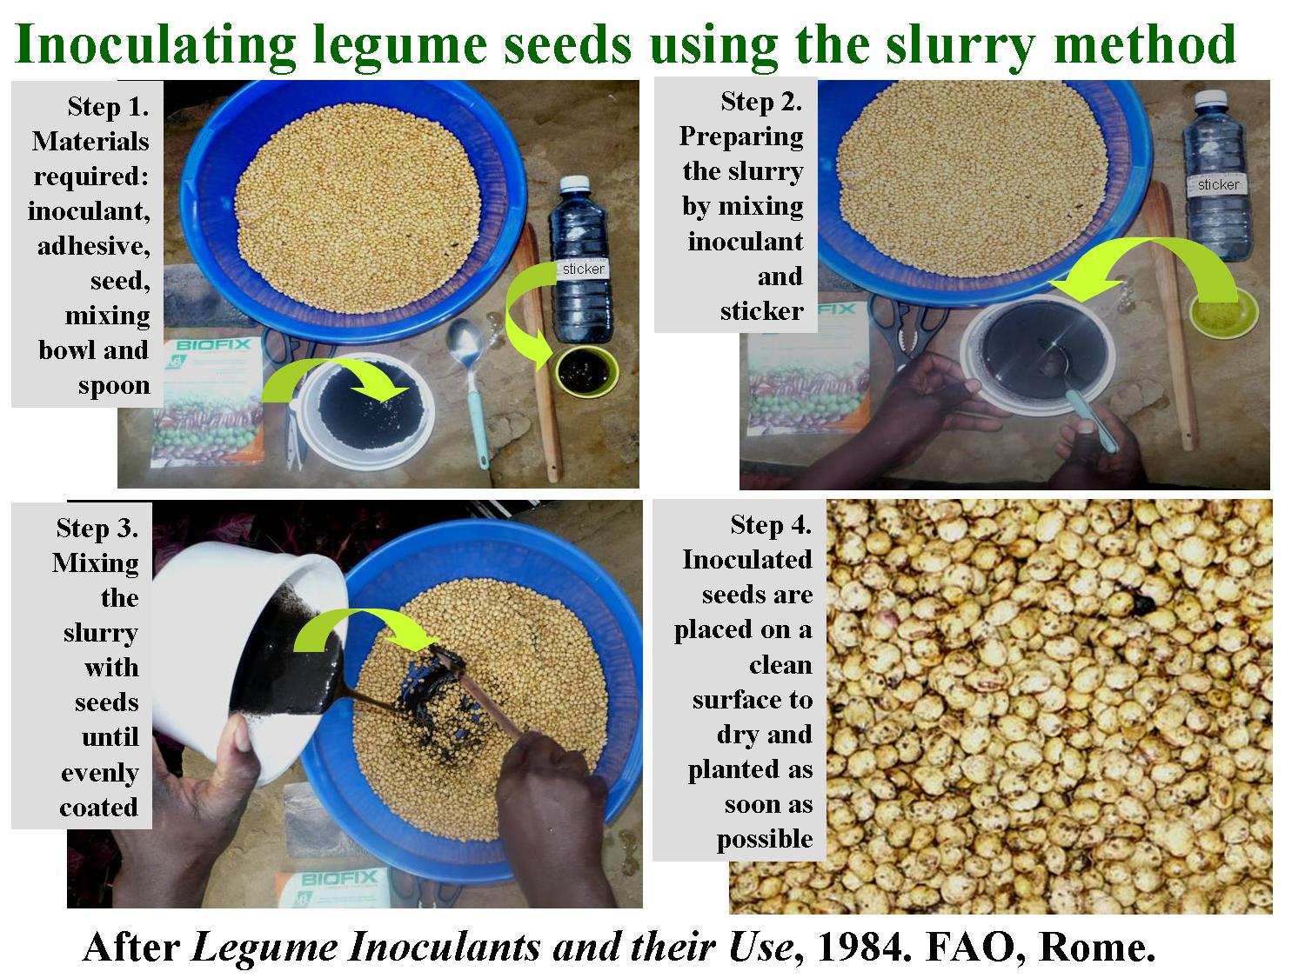

Figure x. The slurry technique first mixes the inoculant and adhesive and then combines them with the legume seed.

Place 1 kg of soybean seeds into a plastic bag. Add 20 ml of water (1 level teaspoon plus 1 level teaspoon). Inflate the bag and twist it shut in such a way that the walls of the bag are rigid. Shake the bag vigorously for about one minute until the seeds are uniformly coated. Open the bag and add 10 g of BIOFIX inoculant (two heaping teaspoons). Close the bag as before and shake again, but more gently for one minute. Note that too vigorous or prolonged shaking may dislodge the inoculant from the seeds. Immediately after coating, spread the seeds on paper and allow them to dry in a shady place. Mark the paper sheet as holding a 2-step-water preparation. Repeat the coating procedure with the following treatments:

* 1 kg of soybean seed wetted with 20 ml of the 30% gum arabic solution and then coat with 10 g of BIOFIX inoculant. Immediately after coating, spread the seeds on paper and allow them to dry in a shady place. Mark the paper sheet as holding a 2-step-gum arabic preparation This procedure is described in Figure x.
* 1 kg of soybean seed wetted with 20 ml of 15% sugar solution and then coat with 10 g of BIOFIX inoculant. Immediately after coating, spread the seeds on paper and allow them to dry in a shady place. Mark the paper sheet as holding a 2-step-sugar solution preparation.

There should now be six different preparations of inoculated seed spread on marked paper sheets. Compare the three different two-step inoculated seeds to one another and the slurry inoculations (Table x). When we compare the two-step and slurry treatments, the seeds from some of the preparations appear darker in color. This indicates that more inoculant was applied to each seed by this method. Rank the six preparations by appearance on a scale of 1 (no inoculant on seed) to 5 (darkest appearance).

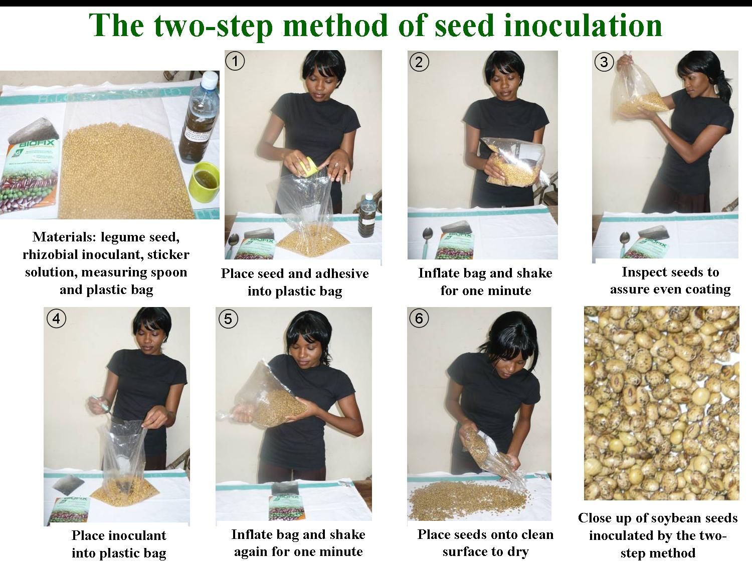

Figure x. The two-step procedure first combines legume seed and adhesive, and then mixes them with the rhizobial inoculant.

**Comment.** The two-step method allows for more inoculant to be applied to the seed, especially when gum arabic is employed as an adhesive. If we used for instance, 30 ml of the sticker, we could coat as much as 100 g of inoculant onto 1 kg seeds, which results in 10 million rhizobia per seed if the inoculant contains one billionrhizobia per gram. Such a rate is, however, excessive as it is not cost effective for farmers under normal conditions. To apply more than this amount of sticker is not practical because the seeds would clump if more than 30 ml of sticker per kg of soybean seeds is applied

Table x. A template for comparing the results of different seed inoculation procedures.

|  |  |  |
| --- | --- | --- |
| Adhesive | Inoculation procedure | |
|  | Slurry | Two-step |
|  | -------------- ranking (1 to 5) ---------------- | |
| Water |  |  |
| Sugar solution (15%) |  |  |
| Gum Arabic solution (30%) |  |  |

**4. Inoculating larger amounts of seed**

The upper limit for inoculating seed using plastic bags is about five kg using the two-step method, otherwise the risk of puncturing the bag and spilling seed and inoculant grows too great. A more useful container for larger amounts of seed (e.g. 10 kg batches) is a 20 liter plastic basket with a lid. In this case, place 10 kg of seed into the plastic bucket and add 200 ml of 40% gum arabic solution. Close the lid and shake for one minute. Open the container and inspect to assure that the seeds are evenly coated, not clumped together and that no sticker is clinging to the walls. Add 100 g of inoculant (or an entire packet of BIOFIX inoculant) and again close the lid. This time shake more gently for one minute, open the lid and inspect seeds for uniformity coating. If coating is not complete, immediately continue shaking for 30 seconds. After coating, spread the seeds out on a clean canvas. After the seeds have dried, place them back into the bucket and store under cool, shaded conditions until sowing as soon as possible. Even larger amounts of seed (e.g. 20 to 40 kg) may be inoculated using a large plastic or canvas sheet, mixing the seed and adhesives and inoculants by rolling.

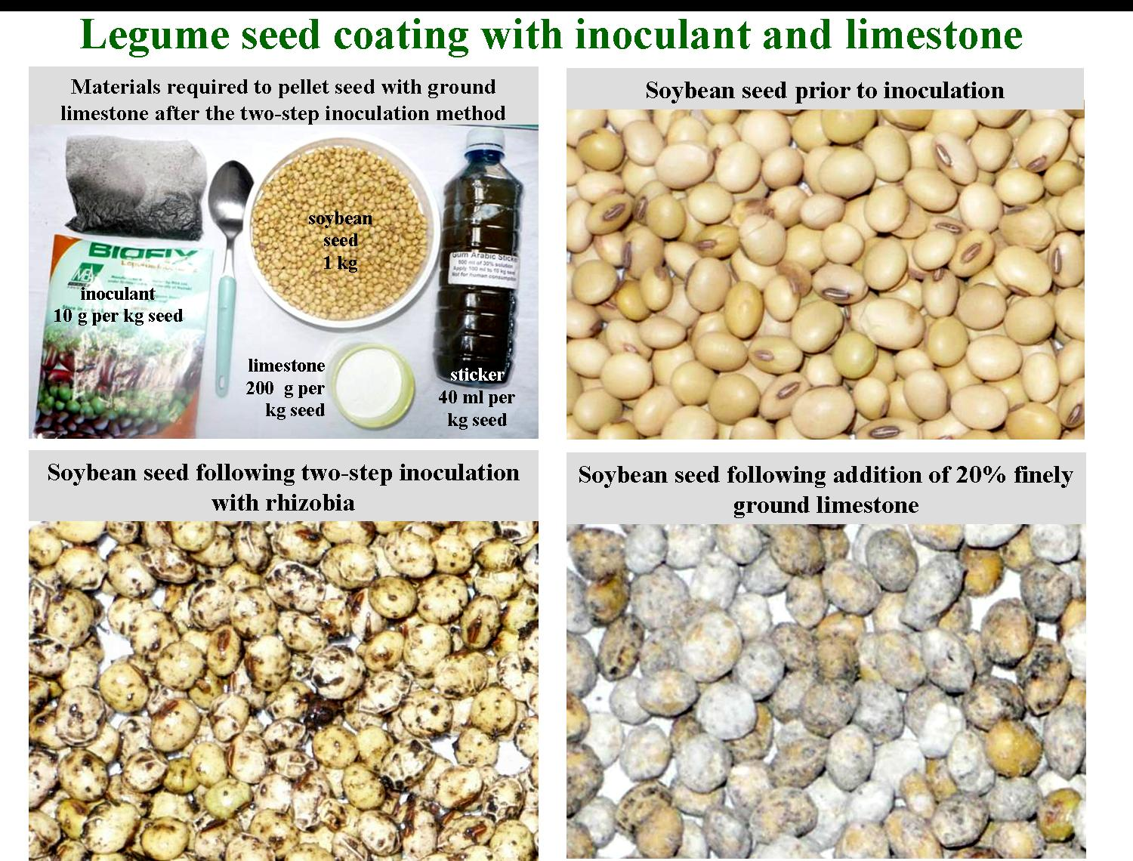

Illustration 3. Seed coating with limestone may be performed following inoculation with rhizobia but requires that additional adhesive be applied.

**5. Pelleting Seeds**

**Pelleting after slurry application.** Make a slurry from 40 ml of gum arabic solution and 10 g of inoculant. Place one kg of soybean seeds in a 3 liter plastic bucket and add the slurry. Stir the mixture until uniformly covered. Spread the seeds on a clean paper sheet and add 200 g of finely ground limestone (or rock phosphate). Roll the seeds on the paper sheet until they are evenly pelleted. Spread the seeds across the paper sheet and allow them to dry (see Illustration 3).

**Pelleting after the two step method of inoculation.** Place one kg of soybean seeds into a plastic bag and add 40 ml of gum arabic sugar sticker. Close bag and shake until the adhesive evenly coats the seed. Add 10 g of inoculant and shake gently for one minute. Open the bag and add 200 g of limestone and again shake gently until all seeds are uniformly coated. Spread pelleted seeds on paper and allow to dry.

Compare the two preparations for evenness of coating, firmness of pellet and amount of calcium carbonate adhering to the seed. Note that to accommodate the pelleting material, more sticker must be applied. Water alone is unsuitable for pelleting because it does not produce a firm, evenly coated pellet.

**6. Determining the Number of Viable Rhizobia on Seeds**

The number of rhizobia on the inoculated soybean seeds of inoculation technique and adhesive (3 techniques x 3 stickers) will be determined immediately after inoculation but should also be performed after 1, 3, 5 and 7 days to better understand the viability of rhizobia following seed inoculation. Remove 10 inoculated seeds from the slurry, two-step and pelleted techniques for each of the three adhesive batches (water, 15% sugar solution and 30% gum arabic).  Make two subsamples of five seeds from each of the nine treatments.

Transfer each subsample into a screw‑capped test tube containing 5 ml of sterile diluent.  Shake the test tubes vigorously for 5 minutes to wash the inoculum off the seeds.  One ml of the resultant suspension will contain the rhizobia derived from one seed.  Make a serial dilution from 10‑1 to 10‑5 from each subsample.

Plate 0.1 ml of each dilution by the spread plate method on YMA plates containing Brilliant Green (1.25 μ/ml) and on YMA plates containing Congo Red (25 μ/ml).  The Brilliant Green will suppress fungal growth while Congo Red will aid in detecting contaminants.

Count the rhizobial colonies and express the results as number of viable rhizobia per seed basis.  For longer term study, convert viable rhizobia per seed to per cent of 0 day viability.  Enter both these data side by side.  Organize the results of all counts as in Table x.

Table x. Viability of rhizobia per seed as affected by different methods of inoculation.

|  |  |  |  |
| --- | --- | --- | --- |
| Inoculation technique | -------------------------------- adhesive used ------------------------------- | | |
|  | water | Sugar solution (15%) | Gum arabic (30%) |
|  | ------------------------------ rhizobia per seed ----------------------------- | | |
| Slurry |  |  |  |
| Two-step |  |  |  |
| Two-step pelleted |  |  |  |

**Appendix 1: Preparing Rhizobium Culture Media**

**Preparation of Yeast-Mannitol Broth (YMB)**

***Constituents***

Mannitol 10.0 g*

K2HPO4 0.5 g

MgSO4.7H2O 0.2 g

NaCl 0.1 g

Yeast Extract 0.5 g

Distilled Water 1.0 liter

Mannitol may be reduced to as low as 1 g l-1.

1. Add mannitol and salts to 1 l distilled water
2. Dissolve under continuous stirring
3. Adjust pH to 6.8 with 0.1 N NaOH
4. Autoclave at 121°C for 15 min.

**Preparation of Yeast Mannitol Agar (YMA)**

***Constituents***

Yeast Mannitol Broth 1,0 liter

Agar 15 g

1. Prepare YMB as described above
2. Add agar, shake to suspend evenly, autoclave.
3. After autoclaving, shake flask to ensure even mixing of melted agar with medium.

## **Incorporating dyes into agar media**

***Bromthymol Blue (BTB):*** Prepare stock solution of 0.5 g BTB/100 ml ethanol, add 5 ml stock/liter YMA, final concentration of BTB is 25 ppm.

***Congo Red (CR):*** Prepare a stock solution of 0.25 g CR/100 ml, add 10 ml stock/liter YMA. final concentration of CR is 25 ppm.

**Preparation of Lower Cost Fermentor Broth**

***Constituents per liter:***

Mannitol 2.0 g

Sucrose 10.0 g

Tripotassium phosphate (K3PO4) 0.2 g

Monopotassium phosphate (KH2PO4) 0.4 g

Magnesium sulphate (MgSO4.7H2O) 0.2 g

Sodium chloride (NaCl) 0.06 g

Calcium carbonate (CaCO3) 0.2 g

Calcium sulphate (CaSO4.H2O) 0.04 g

Yeast Extract 0.5 g

Ammonium phosphate [(NH4)2HPO4] 0.1 g

Water 1.0 l

**Micronutrient – Stock Solution**

***Constituents***

Boric Acid (H3BO3) 2.78 g

Manganese sulphate (MnSO4.7H2O) 1.54 g

Zinc sulphate (ZnSO4.7H2O) 0.21 g

Sodium molybdate (Na2MoO4) 4.36 g

Ferric chloride (FeCl3.6H2O) 5.00 g

Cobalt sulphate (CoSO4.6H2O) 0.004 g

Lactic acid (88%) 580 ml

Distilled water 420 ml

Addition of 1.0 ml per liter of medium gives: boron 0.5 μg; manganese 0.5 μg; zinc 0.05 μg; molybdenum 1.0 μg; iron 100 μg and cobalt 0.0005 μg per liter.

1. Dissolve mannitol, sucrose, yeast extract and salts in 1 liter distilled water
2. Add 1 ml of micronutrient stock solution
3. Autoclave at 121°C for 15 min.

**Appendix 2: Preparing Gram and Carbol Fuchsin Stains (from A3)**

**Solutions for Gram Stain**

***Solution I: Crystal violet solution***

Crystal violet 10 g

Ammonium oxalate 4 g

Ethanol 100 ml

Water (distilled) 400 ml

***Solution II: Iodine solution***

Iodine 1 g

Potassium iodide 2 g

Ethanol 25 ml

Water (distilled) 100 ml

***Solution III:*** 95% Ethanol

***Solution IV: Counterstain***

2.5% Safranin in ethanol 10 ml

Water (distilled) 100 ml

## **Carbol Fuchsin Stain**

Basic fuchsin 1 g

Ethanol 10 ml

5% phenol solution 100 ml

The fuchsin stain should then be diluted 5-10 times with distilled water before use.

**Appendix 3: Broughton and Dilworth N-free Plant Nutrient Solution**

***Constituents***

|  |  |  |  |  |  |
| --- | --- | --- | --- | --- | --- |
| Stock  Solutions | Element | M | Form | g/l | M |
| 1 | Ca | 1000 | CaCl2•2H2O | 294.1 | 2.0 |
|  |  |  |  |  |  |
| 2 | P | 500 | KH2PO4 | 136.1 | 1.0 |
|  |  |  |  |  |  |
| 3 | Fe | 10 | Fe-citrate | 6.7 | 0.02 |
|  | Mg | 250 | MgSo4•7H2O | 123.3 | 0.5 |
|  | K | 250 | K2SO4 | 87.0 | 0.5 |
|  | Mn | 1 | MnSO4•H2O | 0.338 | 0.002 |
|  |  |  |  |  |  |
| 4 | B | 2 | H3BO3 | 0.247 | 0.004 |
|  | Zn | .5 | ZnSO4•7H2O | 0.288 | 0.001 |
|  | Cu | .2 | CuSO4•5H2O | 0.100 | 0.0004 |
|  | Co | .1 | CoSO4•7H2O | 0.056 | 0.0002 |
|  | Mo | .1 | Na2MoO2•2H2O | 0.048 | 0.0002 |

***Preparation***

For each 10 liters of full strength culture solution, add 5.0 ml each of solutions 1 to 4 to 5.0 liters of water, then dilute to 10 liters. Use 1 N NaOH to adjust the pH to 6.6-6.8. For plus N control treatments, KNO3 (0.05% or 0.5 g/l) is added resulting in a N concentration of 70 ppm.

**Appendix 4: Building a Growth Rack for Growth Pouches**

In an effort to keep growth pouches standing upright, researchers have improvised different types of racks. Gramophone record holders have frequently been used for this purpose. More suitable racks may be built from galvanized or stainless steel wire of at least 14 gauge and a wooden board as shown in Figure A.10. The spacing between the wire frames should be 1-1.5 cm. Tools needed are: a drill with a bit of a slightly smaller diameter than the wire, wire cutter, small vise, and a hammer.

**Appendix 5: Surface Sterilization of Grain Legume Seeds**

Figure A.10. Improvised rack for growth pouches

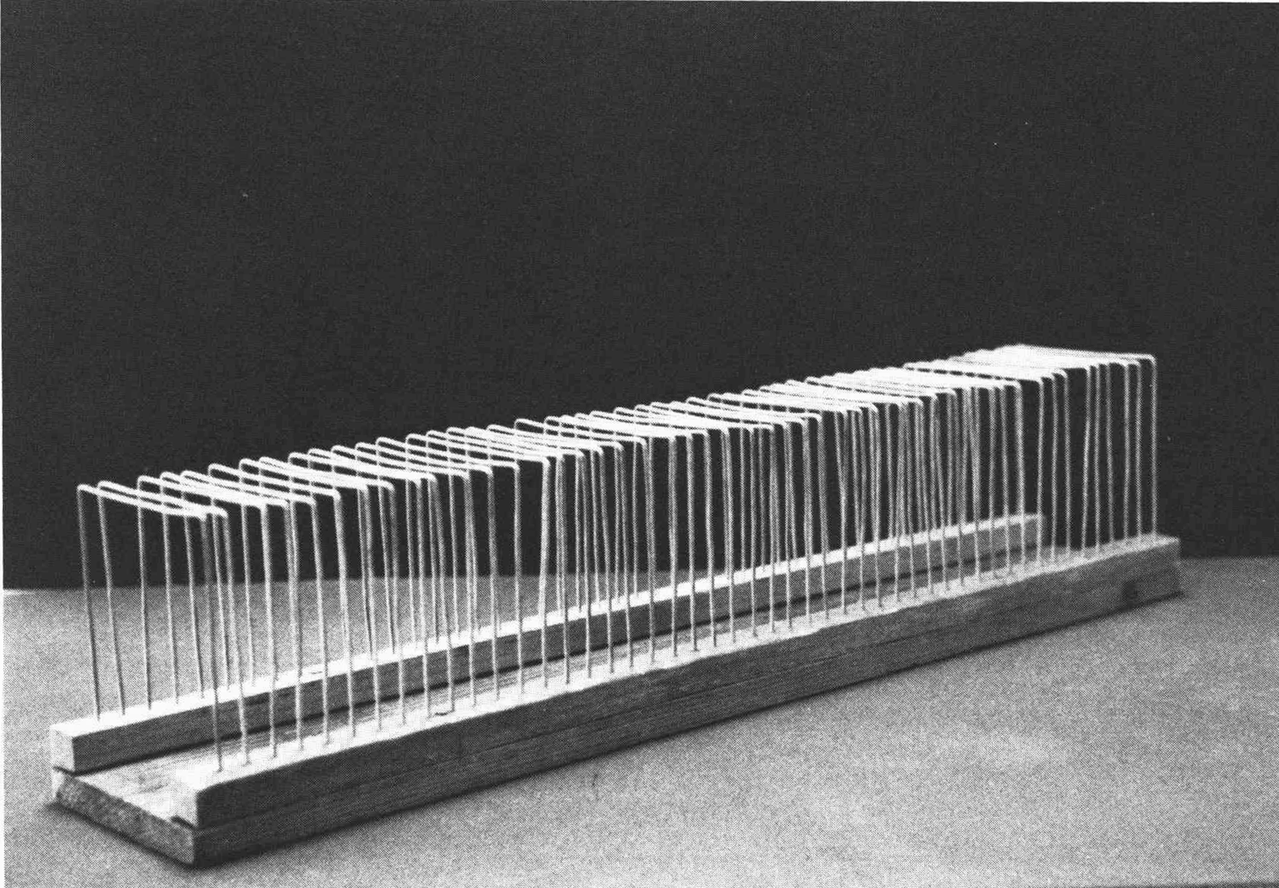

Surface sterilization of legume seeds is dependent on the purpose and nature of the experiment.  Authentication, strain selection and the enumeration of rhizobia by the plant-infection technique require legumes to be raised from surface sterilized seeds to ensure strict microbiological control. Sterilants frequently used for surface sterilizing seeds are solutions of sodium hypochlorite (2.5% commercial bleach) or hydrogen peroxide (3%). Seeds must be of good viability (more than 70%), clean, and free of damage. Treated seeds (pesticides, fungicides or insecticides) must be rinsed quickly in water then dried on paper towels. A procedure to sterilize seeds with mercuric chloride, sodium hypochlorite, or hydrogen peroxide solutions follows.

1. Place seeds in Erlenmeyer flask (wide‑mouthed and previously sterilized by autoclaving). Cover the mouth of the flask with half of a sterile Petri dish. The space taken up by the seeds should be about 25% of the volume of the flask as too many seeds will affect the efficiency of the sterilization. The Petri dish cover should be kept in place throughout the operation.
2. Rinse the seeds in 95% alcohol for 10 seconds to remove waxy material and trapped air. Drain off the alcohol.
3. Add sodium hypochlorite or hydrogen peroxide solutions in sufficient volumes to immerse the seeds completely.  Swirl the contents gently to bring the seeds and sterilant into contact.  After 3‑5 min, drain off the sterilant.
4. Rinse with at least six changes of sterile water.  Observe aseptic procedures throughout the rinsing.  After the sixth rinse, pour in sufficient water to submerge the seeds for 1 to 4 hours to imbibe.
5. Rinse the seeds with two or more changes of water. Petri dishes are needed to plate species with large seeds. Large seeded species are conveniently germinated in Petri dishes containing sterile (autoclaved) vermiculite. The vermiculite is moistened and sterilized one day in advance.
6. Incubate seeds at 25‑30°C and inspect regularly to assure that the radical does not become too long or etiolated.  **Appendix 6: Preparing Leonard Jars**

Figure x. Cross-section diagram of a Leonard jar.

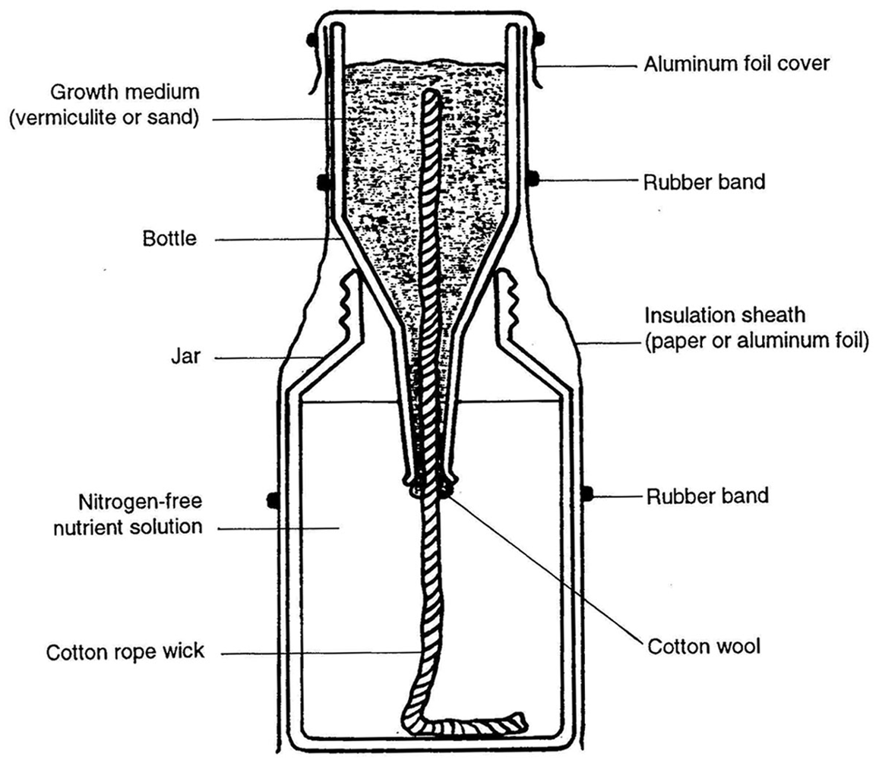

The modified Leonard jar assembly (Figure x) consists of a 500 to 700 ml capacity beer bottle with the lower portion cut off.  This bottle is inverted into a heavy glass jar (reservoir), 1-2 l capacity. The mouth of the bottle should be 2‑3 cm above the base of the reservoir.  The growth medium (sand or vermiculite) in the bottle is irrigated by a centrally positioned cotton wick running the length of the bottle and extending out of the mouth and into the reservoir containing the nutrient solution.  Various types of wick material have been used with Leonard jars, e.g. braided cotton lantern wicks, cotton rope, strands from cotton mop heads, coiled cotton wool, braided or twisted nylon rope.  New wick materials should be tested for their ability to conduct water and their compatibility with plants.  Generally, a 12 mm cotton rope is adequate and easy to obtain.

Place approximately 50 cm of wick material in the bottle with about 10 cm extending out of the mouth.  A small amount of absorbent cotton stuffed into the neck of the bottle will aid in securing the position of the wick, and prevent the growth medium from settling in the reservoir.  Wick material of cotton rope should be boiled in water and squeezed dry prior to use.  This removes air trapped in the wick and improves water conductivity. While holding the wick in a central position, fill the bottle with growth medium (well-washed river sand or horticultural grade vermiculite).  Pack the medium to minimize air spaces.  Sand is easier to pack when dry.  For vermiculite, it is more convenient to pack when wet.  The vermiculite should be soaked overnight and the water drained off prior to packing into the bottles.

Position the bottle in the reservoir.  The bottle should fit firmly on the rim of reservoir.  Moisten the growth medium in the bottle by adding 150‑200 ml of the N‑free nutrient solution.  Allow the nutrient solution to saturate the medium and the excess to drain into the reservoir.  Fill the reservoir with 800 ml of the nutrient solution.  Use 1600 ml if the reservoir has a 2 l capacity.  Wrap the bottle and jar assembly with white or brown moisture-proof paper and secure with rubber bands at critical points along the jar.  Tape may also be used.  Aluminum foil wrapping may be used if it is inexpensive and available.  Cap the open end of the bottle with either aluminum foil or wrapping paper.  Hold the assembly by the reservoir when moving it.

Sterilize the complete assembly and nutrient solution by autoclaving for 1.5‑2.0 hours at 121°C and 15 psi.  For convenience, cool the assembly in the autoclave overnight.

**Appendix 7: Calculating Most Probable Number**

|  |  |  |  |  |  |
| --- | --- | --- | --- | --- | --- |
| No. of positive results | | ratio of dilution series | | | |
| 1-2-3-4-5-6 | 2 | 3 | 4 | 5 | 10 |
| 1-0-0-0-0-0 | 0.2 | 0.5 | 0.8 | 1.1 | 2.5 |
| 1-1-0-0-0-0 | 0.5 | 1.1 | 1.7 | 2.2 | 5.1 |
| 2-0-0-0-0-0 | 0.5 | 1.2 | 1.8 | 2.5 | 5.9 |
| 2-1-0-0-0-0 | 0.9 | 1.9 | 2.9 | 3.9 | 9.2 |
| 3-0-0-0-0-0 | 1.0 | 2.0 | 3.3 | 4.5 | 11 |
| 3-1-0-0-0-0 | 1.3 | 2.9 | 4.6 | 6.4 | 15 |
| 3-2-0-0-0-0 | 1.7 | 3.9 | 6.2 | 8.7 | 21 |
| 4-0-0-0-0-0 | 1.4 | 3.3 | 5.5 | 8.0 | 23 |
| 4-1-0-0-0-0 | 1.9 | 4.5 | 7.7 | 11 | 36 |
| 4-1-1-0-0-0 | 2.4 | 5.7 | 10 | 15 | 54 |
| 4-2-0-0-0-0 | 2.4 | 6.0 | 11 | 16 | 61 |
| 4-2-1-0-0-0 | 3.0 | 7.5 | 14 | 22 | 93 |
| 4-3-0-0-0-0 | 3.0 | 8.0 | 15 | 24 | 112 |
| 4-3-1-0-0-0 | 3.8 | 10 | 20 | 33 | 159 |
| 4-3-2-0-0-0 | 4.5 | 13 | 25 | 44 | 213 |
| 4-4-0-0-0-0 | 3.9 | 11 | 23 | 40 | 230 |
| 4-4-1-0-0-0 | 4.7 | 14 | 31 | 57 | 359 |
| 4-4-1-1-0-0 | 5.5 | 17 | 40 | 75 | 544 |
| 4-4-2-0-0-0 | 5.7 | 18 | 43 | 81 | 614 |
| 4-4-2-1-0-0 | 6.6 | 23 | 55 | 107 | 926 |
| 4-4-3-0-0-0 | 6.9 | 24 | 60 | 121 | 1124 |
| 4-4-3-1-0-0 | 8.1 | 30 | 78 | 165 | 1593 |
| 4-4-3-2-0-0 | 9.5 | 38 | 102 | 218 | 2130 |
| 4-4-4-0-0-0 | 8.4 | 33 | 91 | 203 | 2305 |
| 4-4-4-1-0-0 | 10 | 43 | 125 | 287 | 3594 |
| 4-4-4-1-1-0 | 12 | 53 | 161 | 380 | 5469 |
| 4-4-4-2-0-0 | 12 | 56 | 172 | 409 | 6137 |
| 4-4-4-2-1-0 | 15 | 70 | 222 | 545 | 9262 |
| 4-4-4-3-0-0 | 14 | 75 | 243 | 611 | 11239 |
| 4-4-4-3-1-0 | 17 | 94 | 319 | 830 | 15926 |
| 4-4-4-3-2-0 | 21 | 119 | 417 | 1113 | 21297 |
| 4-4-4-4-0-0 | 18 | 104 | 374 | 1035 | 230545 |
| 4-4-4-4-1-0 | 22 | 136 | 519 | 1465 | 359439 |
| 4-4-4-4-1-1 | 26 | 170 | 669 | 1992 | 546920 |
| 4-4-4-4-2-0 | 27 | 179 | 719 | 2109 | 613730 |
| 4-4-4-4-2-1 | 32 | 226 | 938 | 2813 | 1123930 |
| 4-4-4-4-3-0 | 33 | 244 | 972 | 3281 | 1592630 |
| 4-4-4-4-3-1 | 41 | 313 | 1272 | 4375 | 2129690 |
| 4-4-4-4-3-2 | 50 | 404 | 1686 | 5938 | 3594390 |
| 4-4-4-4-4-0 | 44 | 355 | 1496 | 5175 | 5469200 |
| 4-4-4-4-4-1 | 55 | 485 | 2072 | 7177 | 6137300 |
| 4-4-4-4-4-2 | 73 | 689 | 2872 | 10228 | 9262000 |
| 4-4-4-4-4-3 | 107 | 1069 | 3988 | 15263 | 11239300 |
| Confidence  factor | 2.00 | 2.40 | 2.67 | 2.88 | 3.80 |

Population density in the original test sample assumes 1-mL inoculation volume. Table generated using MPNES software (Woomer et al., 1990). The confidence factor is divided into and multiplied by the population estimate to establish the lower and upper confidence limits (*P*=0.05), respectively. (After Cochran, 1950).

**Appendix 8: Preparing Inoculant Carrier Materials**

Inoculant carriers may be prepared in the laboratory from peat, or other materials high in organic matter. Peat is usually wet when harvested. It is drained, strained, and shredded then dried at a temperature not exceeding 100oC. Higher drying temperatures should be avoided as it may cause development of toxic substances which may be harmful to rhizobia. The peat is then ground in a hammer mill to a particle size of 10 – 40 microns. Neutralization is achieved by adding calcium carbonate. The calcium carbonate may also be added later by injecting it together with the broth into the carrier sealed in a bag.

Any carrier may be produced similarly from organic matter. Its water holding capacity should be determined by adding a little water at a time until the desired consistency has been reached. The amount of calcium carbonate needed for neutralization should also be experimentally determined by adding a little at a time until a neutral point is reached. Carriers may be heat sealed into thin gauged (1.5 mil) polyethylene or polypropylene (3.0 ml) bags. If sterilization is desired, the sealed polyethylene bags may be gamma-irradiated at 5 Mega rads.

Autoclaving is possible with polypropylene bags which are heat resistant. (Polypropylene bags containing 50-100 g of peat are usually autoclaved for, 60 minutes at 15 lbs pressure, and 121oC). Polyethylene, if not thicker than 1.5 mil, permits air exchange which is thought to be necessary to keep the rhizobia viable. Polypropylene is not permeable to air. Inoculant bags made from this material are usually perforated or sealed with a small cotton plug in the seam to allow for gas exchange.

High density polypropylene is autoclavable and can be used as a container for sterilizing the carrier. However, certain precautions need to be taken when using this material for this purpose. Complete sealing is avoided after the carrier has been placed in the bags. Instead, the open end of the bag is folded down and held in place by a paper clip to allow steam to enter the bags during autoclaving. Also, bags are placed in wire baskets or in trays with perforated bottoms. Bags should be arranged upright with sufficient space between them to allow for steam circulation. After autoclaving, the bags are allowed to cool in the autoclave. The bags are then sealed with a bag sealer in a laminar flow hood or in a simple transfer hood (Appendix 21). The paper clip is removed just prior to sealing.

Alternatively, about three quarters of the open end of the bag is sealed off after placing the carrier in the bag. The remaining unsealed portion is folded down and held by a paper clip. The sealing is completed after autoclaving.